

-9v Inverter
A very compact voltage inverter for use with positive ground effects, being fuzz pedals mainly.
For tight builds, use low profile electrolytic caps (available on the webstore).

Bill of materials
Capacitors | IC
C1 10uf | U1 Charge Pump - I recommend the LT1054 or the low noise TC1044scpa. Check the store for the TC1044scpa!
C2 100uf
C3 10uf | Diode
 | D1 (next to U1) 1n400x

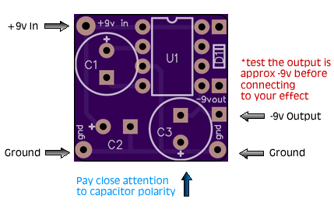

Page 1 of 1

