

10 Min Buffer
The 10 Min Buffer is a very simple and easy to assemble guitar signal buffer with some added extras including reverse polarity protection and input pull down resistor (an anti-pop measure). The buffer has a high input impedance and low output impedance which are desirable characteristics of a signal buffer.

Bill of materials
Resistors | Capacitors
R1 1 meg | C1 100nf (104)
R2 1 meg | C2 10uf
R3 1 meg
IC | Diodes
U1 LM741 / TL071 | D1 1n4001

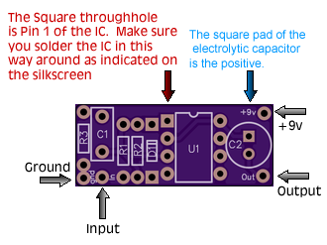

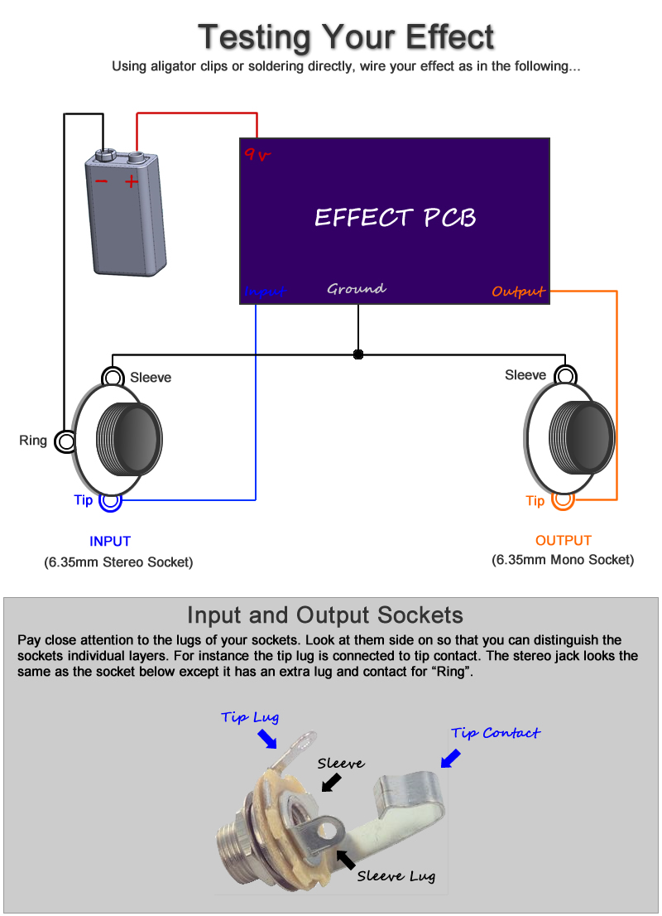

Note, you can still test your effect with 2 mono jacks, just combine the negative of the battery with the ground input sleeve connection.
Offboard Wiring Diagram
Using a non-switched Miniature DC Jacks and 2 Mono Jacks (kit option with diyguitarpedal kits)

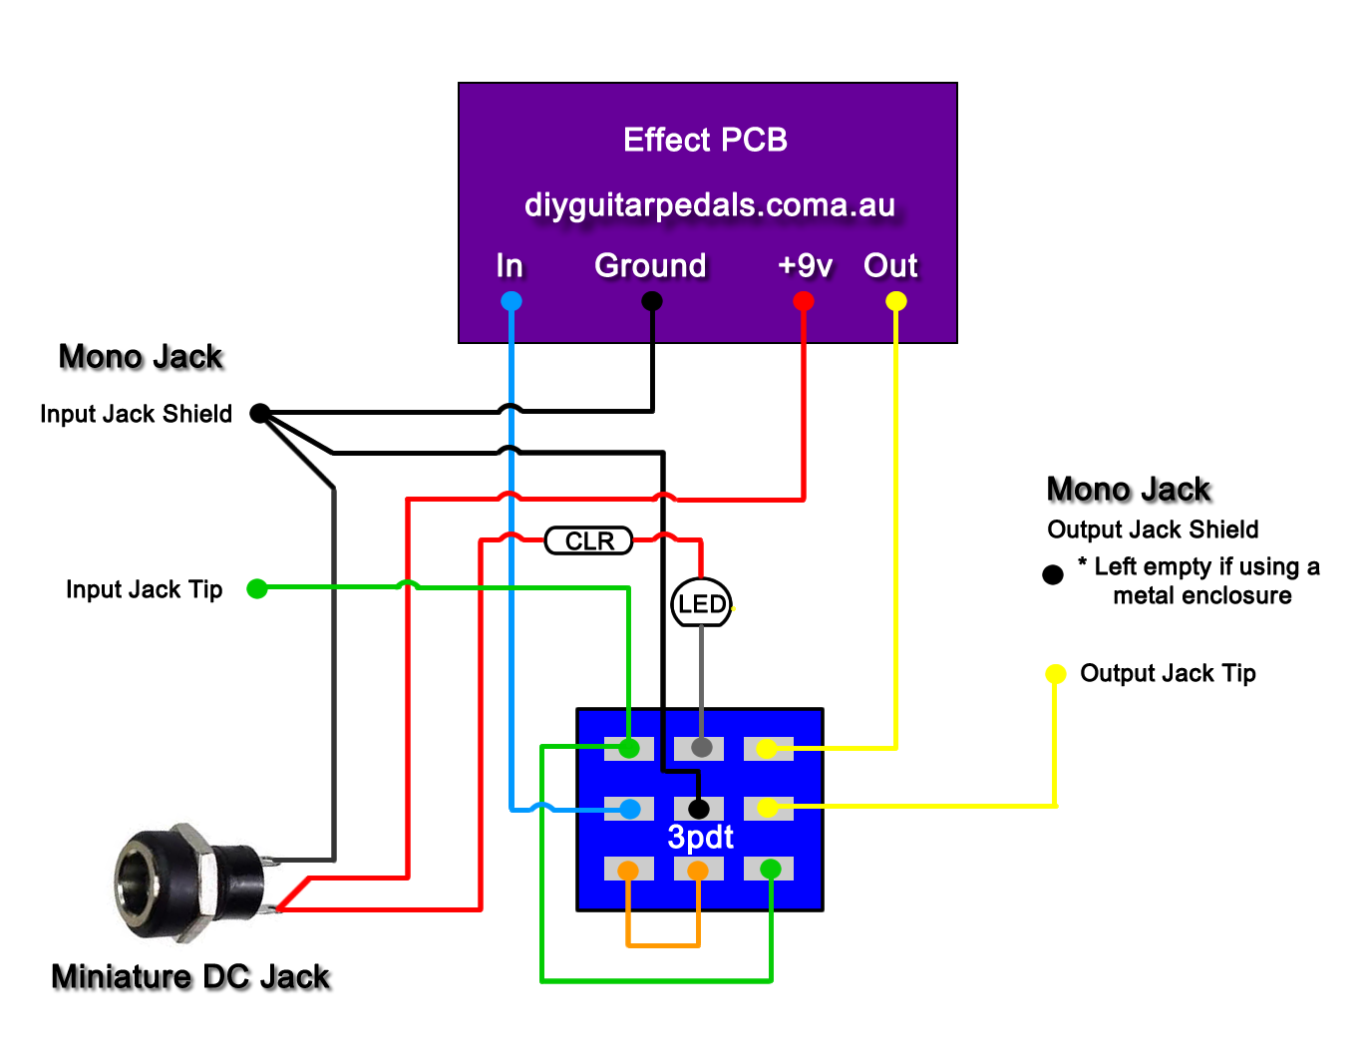
The Lugs of the Miniature DC Jack
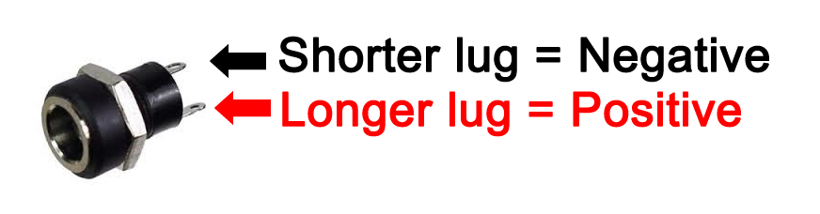
The miniature dc jacks that are sold as a kit option with pcbs have 2 lugs, 1 short and 1 long and should be connected as shown in the picture to the right. To confirm which lug is which, sight done the socket hole, you should be able to see which lug is connected to the pin and which is connected to the barrel of the jack. Also note that miniature dc jacks do not allow for battery switching, they can only be used for DC power.

