
10 Min Dirt & Boost
A transistor booster and overdrive based on the Electra Distortion™ with switchable diode clipping stage. As well as a versatile light overdrive (“dirt”) and boost pedal I find both the clean and dirty output of this effect blends well when used to boost the front end of another overdrive / distortion.

Bill of materials
Resistors | Capacitors | Diodes
R1 3.3k | C1 100nf (104) | D1 1n34a (Any GE Diode)
R2 2.2M | C2 100nf (104) | D2 1n34a (Any GE Diode)
R3 680R
Transistor | Boost Switch | Potentiometer
U1 2n3904 | SW SPDT(on-on) Toggle Switch | Volume 100ka Log

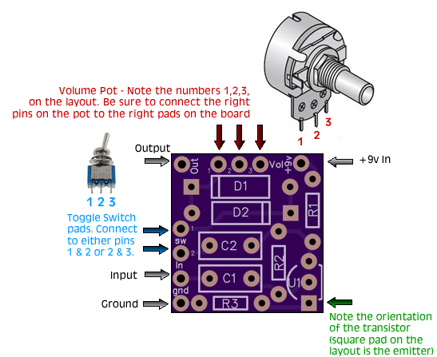

Tip for soldering 9mm Alpha Pots
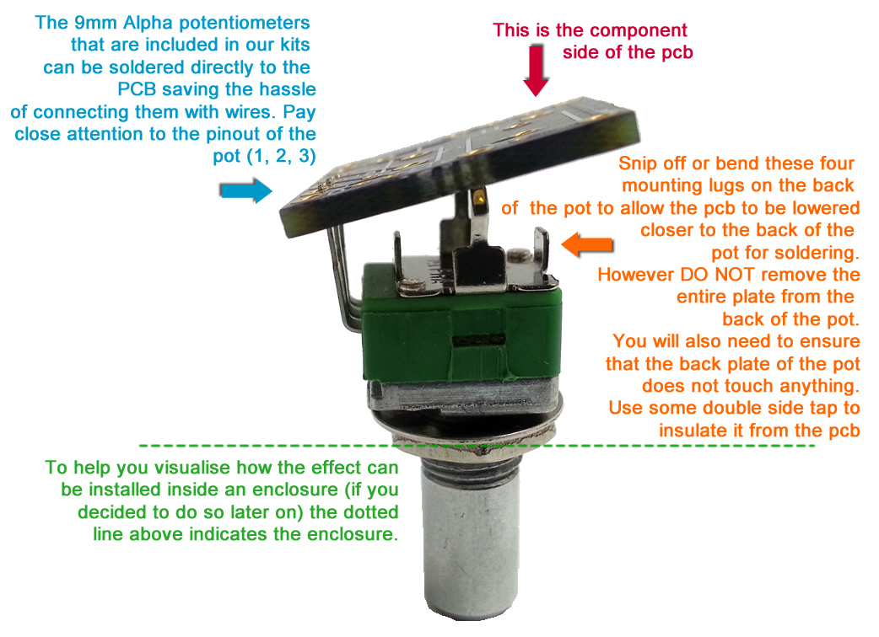
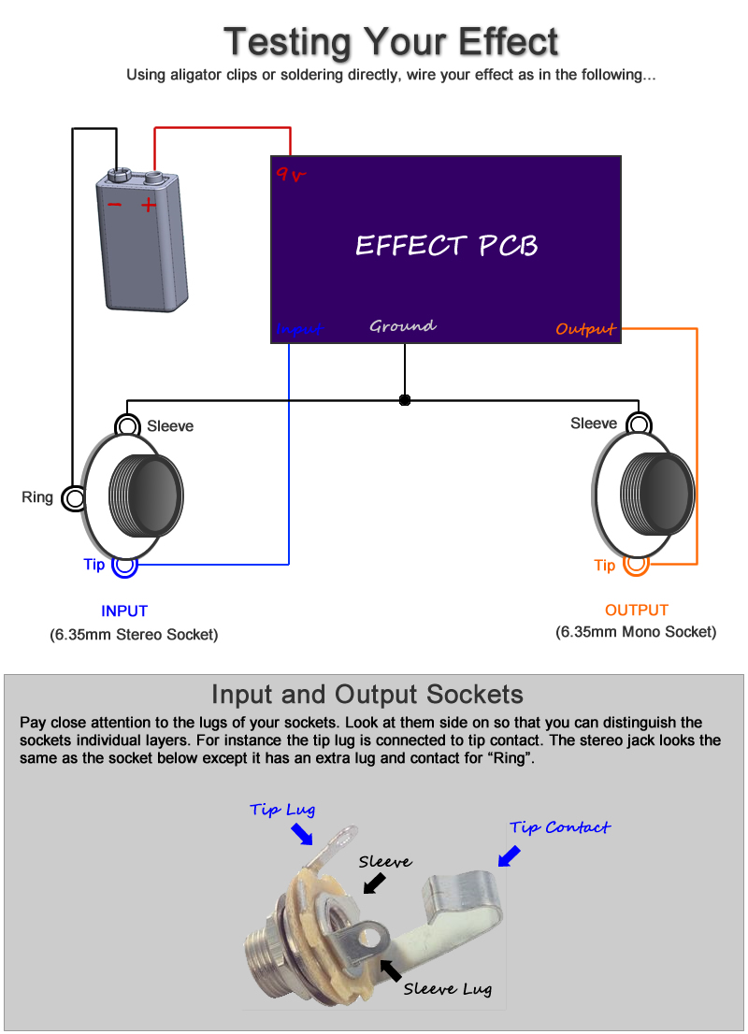

Note, you can still test your effect with 2 mono jacks, just combine the negative of the battery with the ground input sleeve connection.
Offboard Wiring Diagram
Using a non-switched Miniature DC Jacks and 2 Mono Jacks (kit option with diyguitarpedal kits)

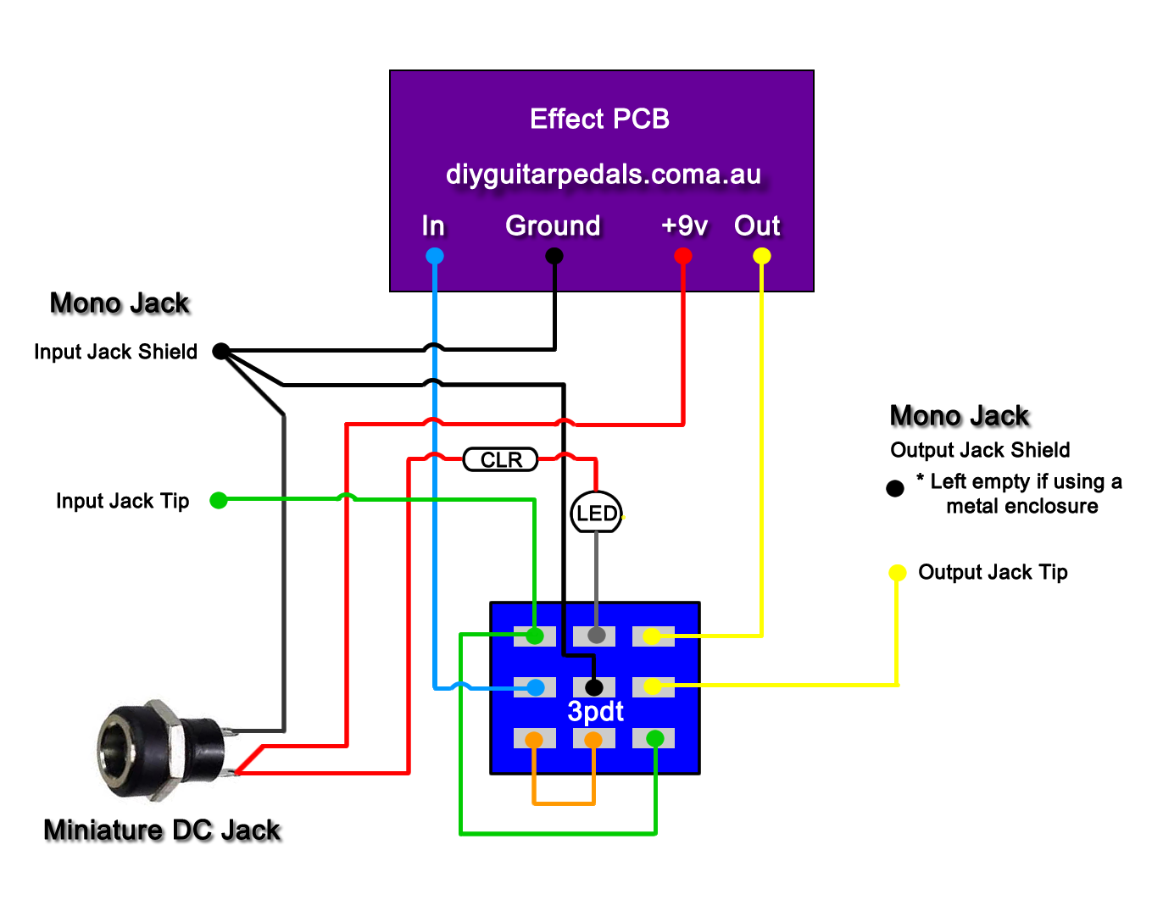
The Lugs of the Miniature DC Jack
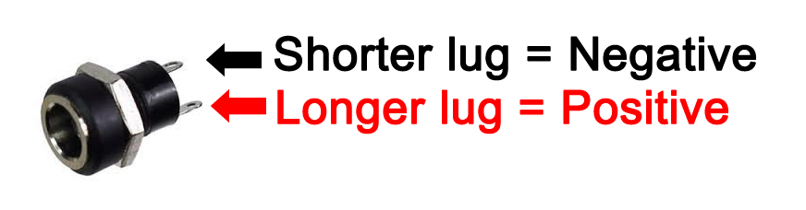
The miniature dc jacks that are sold as a kit option with pcbs have 2 lugs, 1 short and 1 long and should be connected as shown in the picture to the right. To confirm which lug is which, sight done the socket hole, you should be able to see which lug is connected to the pin and which is connected to the barrel of the jack. Also note that miniature dc jacks do not allow for battery switching, they can only be used for DC power.

