

3PDT De-Lux PCB
The 3pdt “De-Lux” PCB allows for direct mounting of the LED, a trimpot to control the brightness of the LED and a more standardized layout for the hardware and effect pcb connections. Both solder lug and pcb mount 3pdt footswitches will fit this pcb.

This pcb will fit into a 1590a enclosure but will be slightly off center. It is recommended to use the “Compact” 3pdt pcb’s (see webstore) for 1590a and other tight builds.

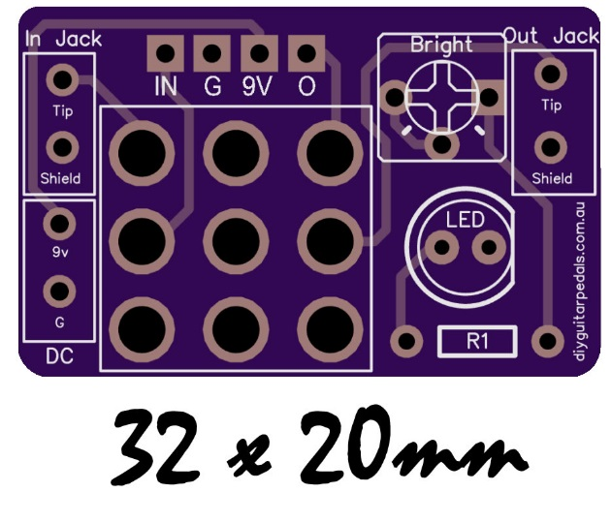

The “Bright” Trimpot
A trimpot (“bright”) can be used for adjustment of the brightness of the effects status led. This should be a horizontal mount miniature trimpot (bournes 3362p) to allow for height clearance inside the enclosure. If using the trimpot option, be sure to add a low resistor value for R1. This will ensure you do not blow the LED when the trimmer is on minimum (zero) resistance. As LED’s vary widely I would recommend 1k resistor for R1 as a standard. 10K should be an ample value for the trimmer.

The resistor (R1), trimpot and led are all in series so they must all be populated or jumpered.
If you do not wish to use the trimpot it can be jumpered. Add a jumper as illustrated by the red line in the below illustration to bypass the trimpot.

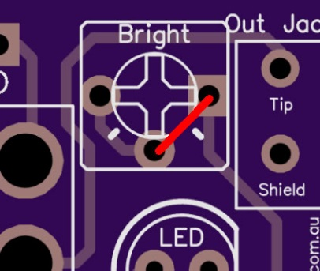

Orientation of the 3pdt
The 3pdt footswitch must be inserted into the pcb in the correct orientation. View the below illustration for guidance on how the 3pdt footswitch should be inserted into the pcb. The correct orentiation of the 3pdt is where the lugs would point in a horizontal direction instead of vertically (see below).

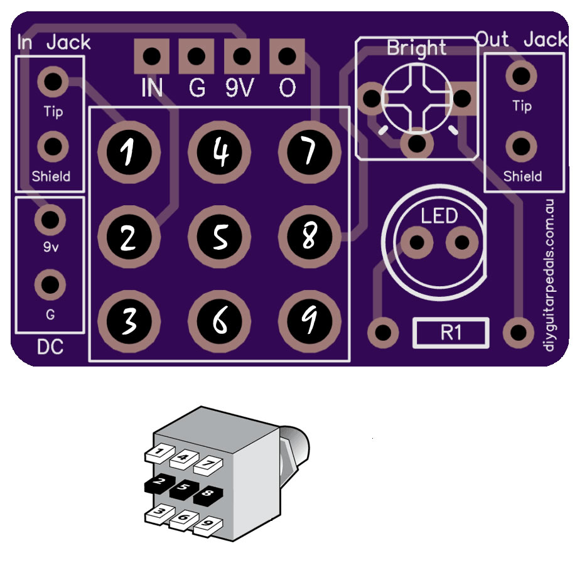

A Tip when Soldering the 3PDT switch lugs
An occasional problem with large plated throughholes on 3pdt pcb’s; when soldering the 3pdt switch lugs to the pcb you may encounter unwanted connections between pads on the underside of the pcb. A few things you should keep in mind to avoid this problem are:
- Pay close attention to how quickly you are feeding solder onto the 3pdt switch lugs. Accidental connections can be made if too much solder is forced onto the switch lug particularly with smaller diameter solder. Allow the solder to melt and flow slowly.
- Also be sure not to add any more solder then is required to make a reliable connection (ie enough is enough).
- Use Solder lug 3pdt switchs when available instead of PCB lug 3pdt switches as there will be less space to fill.

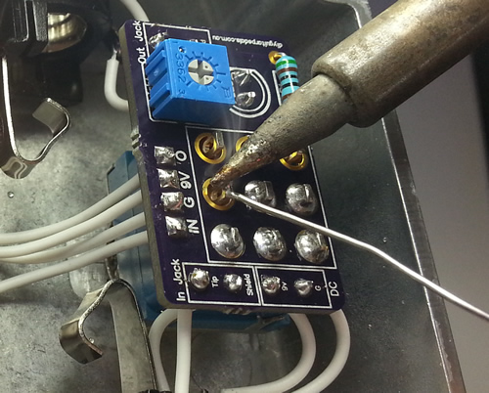

Soldering order
Soldering order is personal preference, however I have found it to be much easier to solder the 3pdt lugs last (as in picture above). For the De-Lux PCB I would encourage soldering the CLR resistor and trimmer first. Then all pcb wires, followed by the LED and LASTLY the 3pdt lugs. Experiement with this order to see which one suits you but I would suggestion soldering the 3pdt lug connections last.

Addition of a battery
You would add battery support to a build that incorporates a de-lux just as you would with any other build. The battery snap is soldering to the switched DC jack and the stereo input socket. The negative of the battery snap connects to the ring of your input stereo socket (the unused lug).

Also connect the negative of the switched dc jack to the to the de-lux pcb. In the below diagram the statement “’G’ on the 3pdt pcb” refers to the ‘G’ inside the “DC” box on the pcb.

