

7 Min Fuzz
The 7 min fuzz is a low part count high-gain circuit that produces a very respectable, thick sounding fuzz tone. However this is just one of the sounds capable from this circuit. It is quite adaptable and if you have purchased the experimenters kit you can follow along with my basic notes on how to tweak it! The BOM below lists the ‘standard’ configuration (thick sounding fuzz).

Bill of Materials
Resistors | Diode
R1 10k | D1 BAT41 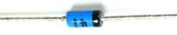
Capacitors | Transistor
C1 1uf (105) 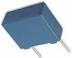 | Q1 MPSA13 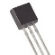
C2 100nf (104)
 | Potentiometer
 | Volume 100ka Log 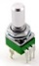
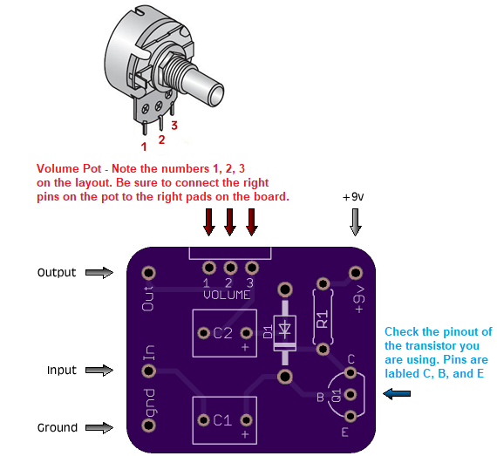

Orientation and Polarity of the Components

Polarity of the BAT41 Diode
Note the polarity of the BAT41 diode. The Band on the diode must match up with the band printed on the circuit board:

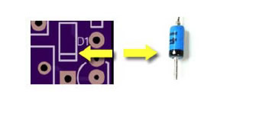

Orientation of the MPSA13 Transistor
The Transistor must also be installed into the circuit the correct way around. Note the image of the transistor printed onto the circuit board. This must be matched with the shape of the body of the transistor.



Orientation of the resistor and capacitors
The resistors and capacitors (film) are not polarized and can be inserted into the circuit board either way

Reference Designators
The reference designator (the letter followed by a number found on the bill of materials, see picture below) identifies the component of an electrical schematic. This Reference Designator (“refdes” for short) also appears on the silkscreened printing on the circuit board. See below an example of the reference designator for R1, a 10k resistor, found on the bill of materials and the printed circuit board. So for R1, we would solder a 10k resistor into this position.
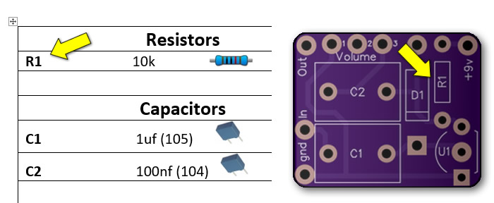

7 Min Fuzz – Bass Guitar Mod
The Capacitors included in the 7 Min Fuzz Kits are selected for electric guitar, however the circuit will work with bass guitar as well with only a small modification; higher value capacitors on the input and output, C1 and C2 (available on the webstore). Film capacitors in values above 1uf are quite expensive, so it’s typical to use electrolytic ones in their place. Electrolytic capacitors in values between 1uf and 10uf would be suitable for experimentation.

Electrolytic capacitors are polarized, one lead is negative the other positive. The positive lead should be connected to the ‘more positive’ side of the circuit. The board should have labels that indicate polarity of the pads on the PCB.
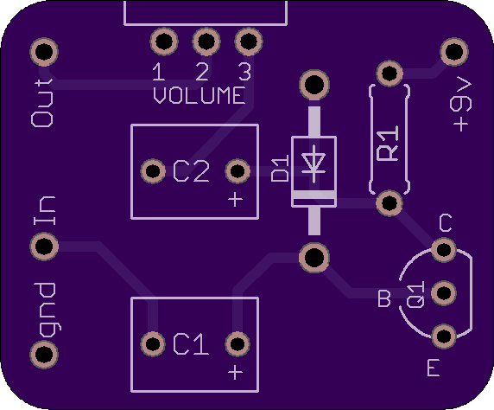

7 Min Fuzz – Gain Control Mod
Adding resistance to the emitter of the 7 min fuzz transistor will reduce the gain of the circuit. We can add a modification for adjusting the gain of the effect by adding a potentiometer to the circuit, a device that increases resistance as you turn the dial.
Check out the wiring diagram below for a visual representation of how to go about adding this gain control and also my video on how to add a Gain control the 7 min fuzz circuit:
(YouTube link)

https://www.youtube.com/watch?v=WCFrhkL1a2I

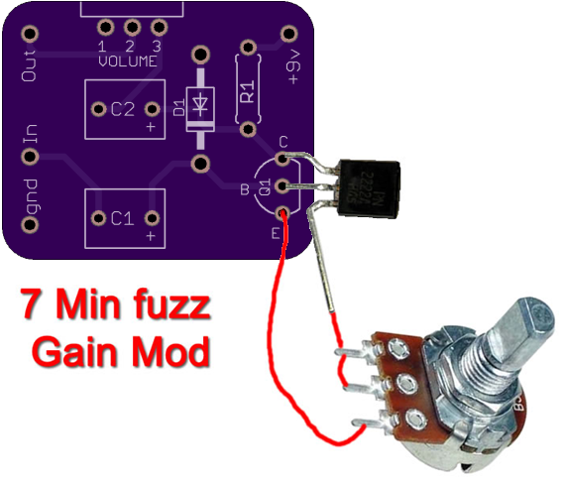

Tip for soldering 9mm Alpha Pots

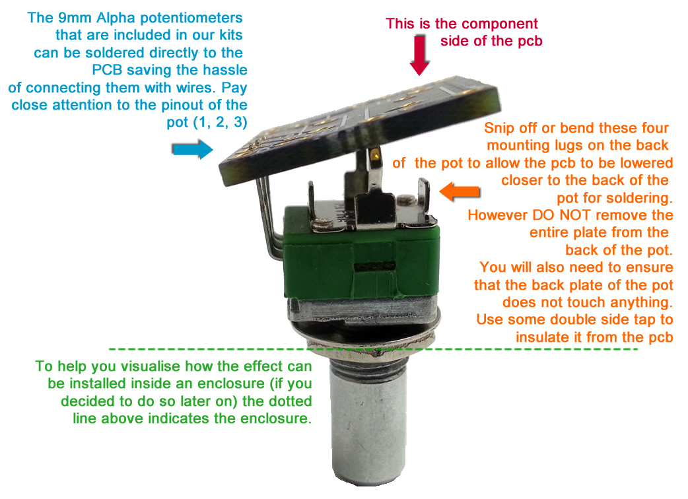

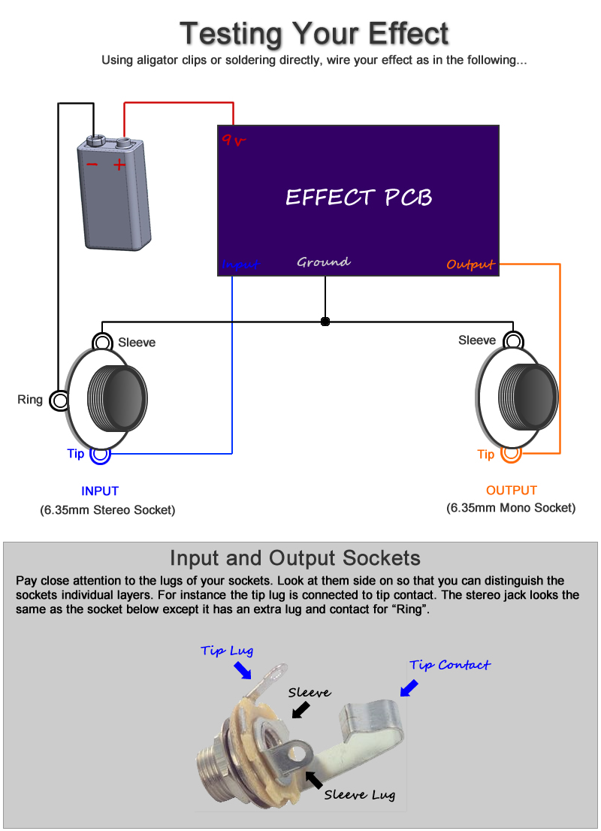

Note, you can still test your effect with 2 mono jacks, just combine the negative of the battery with the ground input sleeve connection. A DC Jack will also work for a power source, replace the battery above with a dc jack.
Off Board Wiring Diagram
Using a non-switched Miniature DC Jacks and 2 Mono Jacks (kit option with diyguitarpedal kits)
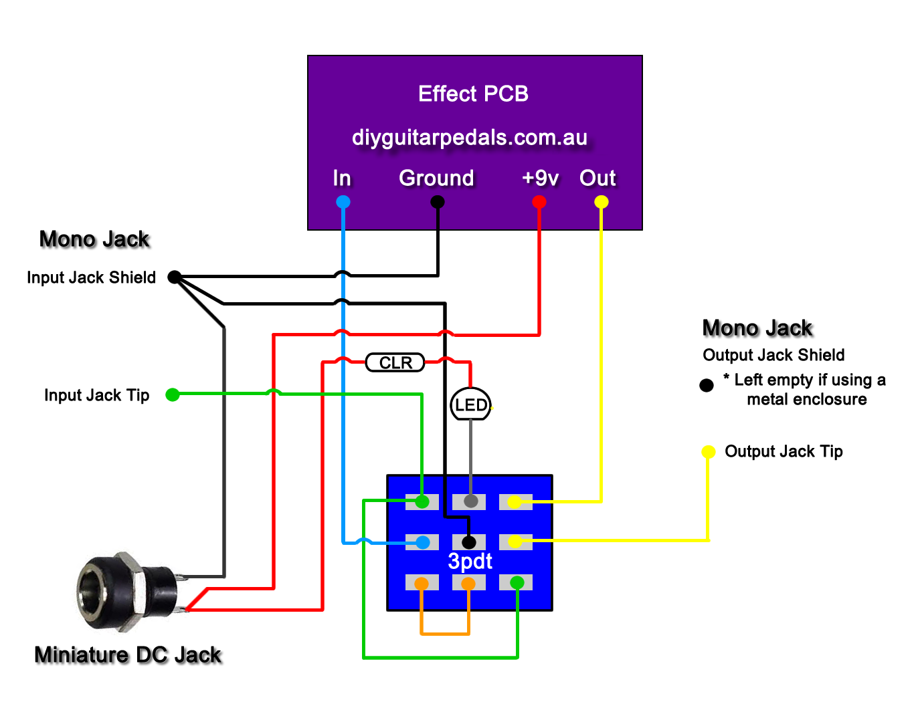
“CLR” = Current Limit Resistor. This resistor (included with your LED and bezel controls the brightness of the led and stops the LED from blowing. Also note the flat side of the LED, examine your LED closely you will note it physically has a flat side. This is the negative side of the led as pictured above
The Lugs of the Miniature DC Jack
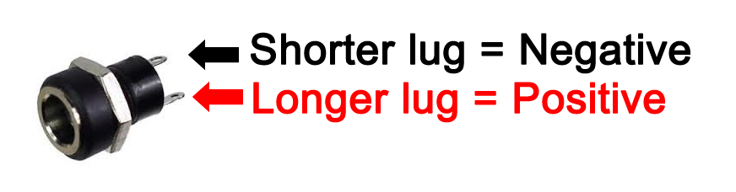
The miniature dc jacks that are sold as a kit option with PCBs have 2 lugs, 1 short and 1 long and should be connected as shown in the picture to the right. To confirm which lug is which, sight done the socket hole, you should be able to see which lug is connected to the pin and which is connected to the barrel of the jack. Also note that miniature dc jacks do not allow for battery switching, they can only be used for DC power.

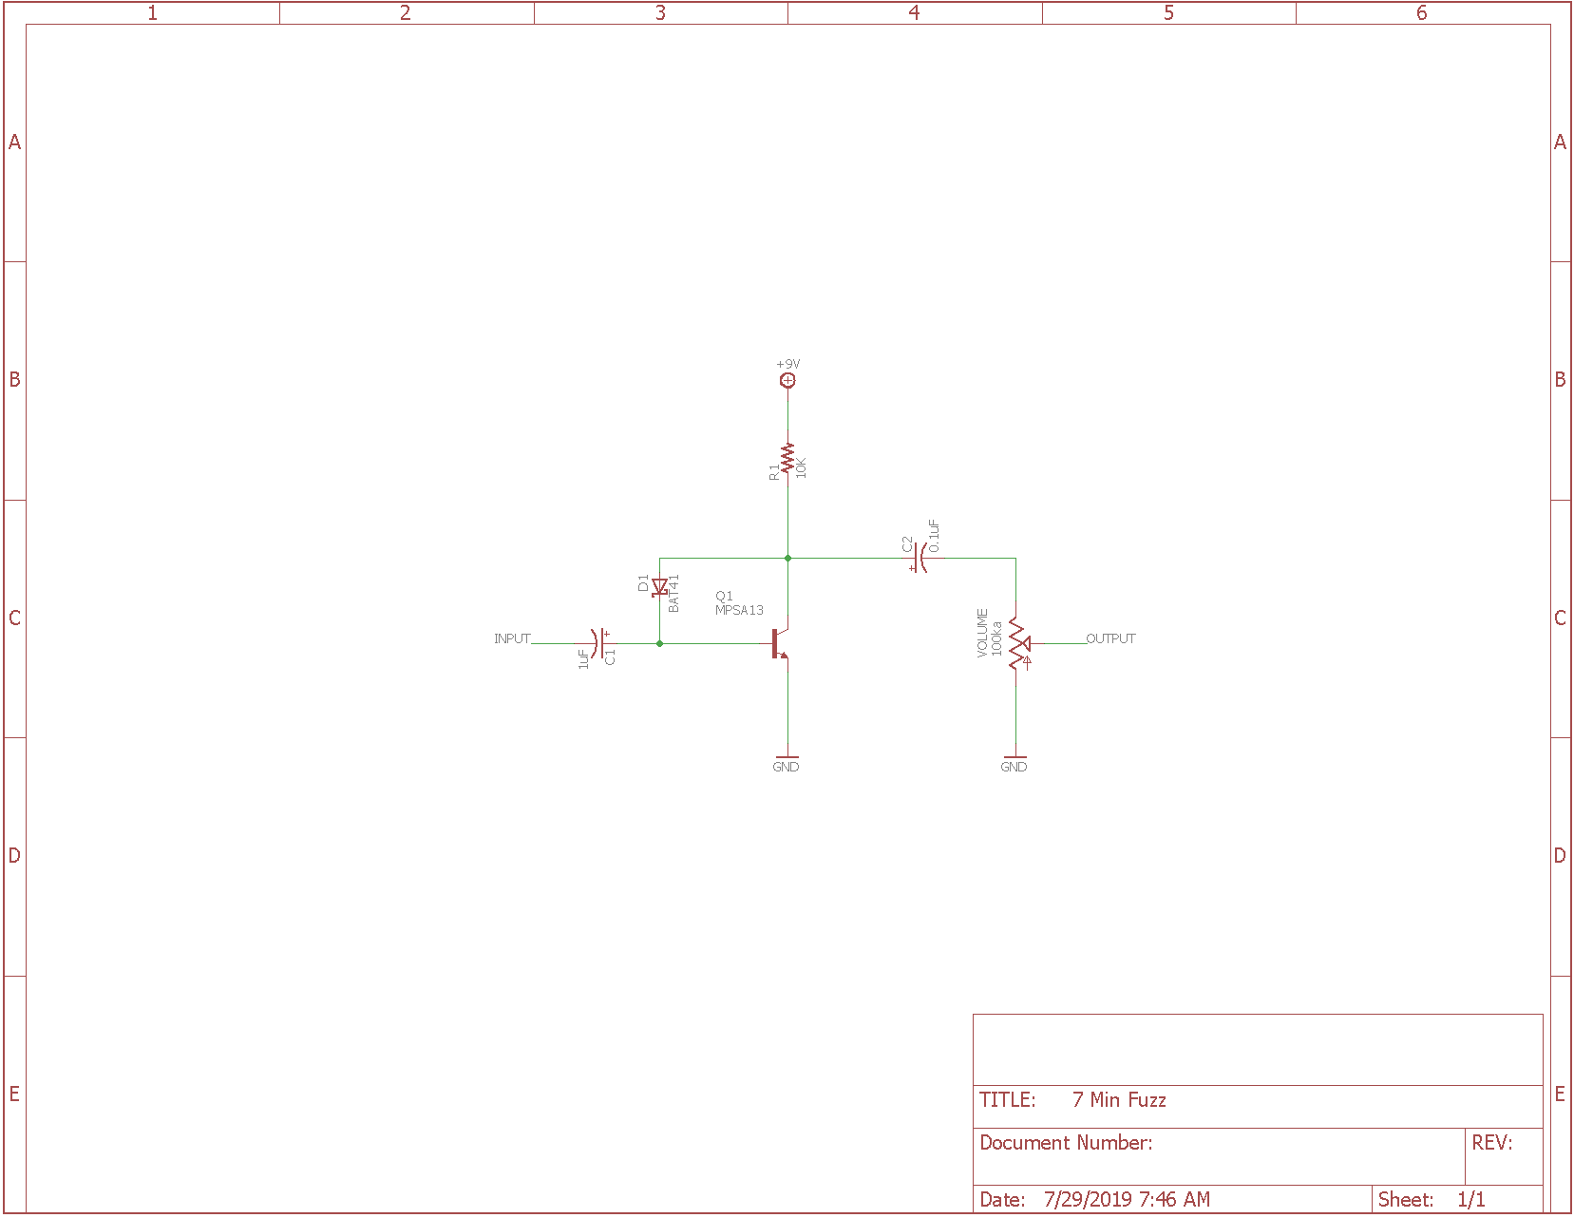

7 Minute Fuzz Circuit Analysis for understanding technical purposes.

1. 7 Minute Fuzz Circuit.
The 7 Minute Fuzz schematic can be broken down into some simpler blocks: Power Supply, Transistor Input and Clipping, and Volume Control.
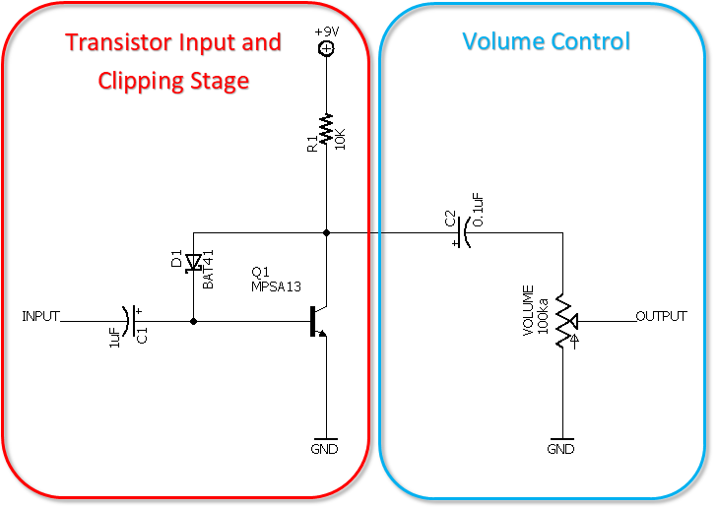
The circuit is designed around a single op-amp gain and hard clipping while using transistors to handle buffering and boosting the input signal and buffering a recovery stage at the end.
The circuit is designed around a single, NPN, bi-polar junction transistor (BJT) or Darlington Pair transistor (2 BJTs butted together into one transistor package) with maximum gain applied to its emitter pin, which is grounded. The single diode uses its voltage drop to bias the base of the transistor below the collector voltage which also provides asymmetrical soft clipping.
The input impedance on the 7 Minute Fuzz is very small, allowing the pedal to overload the pickups on the guitar or to tone suck. Make sure this pedal is in the front of your pedal signal chain to avoid issues.

2. Transistor Input and Clipping Stage.
The single input stage transistor provides the amplification of the signal while also providing some clipping and input/output impedance to the circuit.
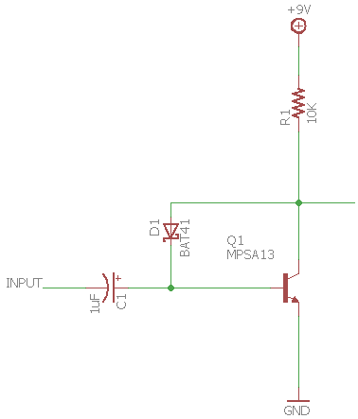
The Q1 transistor just needs to be high-gain (h_{FE} of 5,000 minimum per the MPSA13 datasheet). The lower the h_{FE} value on the selected Q1 transistor, the less saturation and fuzz will occur and the higher the h_{FE} value, more saturation and fuzz.

Example transistors that could be used:
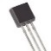  Transistor | h_{FE} min @ V_{CE}=5.0V, I_{C}=1.0mA
MPSA14 | 10,000
MPSA13 | 5,000
MPSA18 | 500
2N5089 | 400
2N5088 | 300
2N5210 | 250
2N3904 | 150
2N4401 | 100

Though positioned schematically as a soft-clipping diode, D1 is not soft clipping in the same way as the diodes in a Big Muff Pi or other soft-clipping transistor fuzz pedals. What it does is bias the base of Q1 to one voltage drop below the collector voltage. Example diode voltage drops.
Diode | Voltage Drop
Silicon Diodes (1N914, 1N4148, etc) | 0.7 V
Schottky Diodes (BAT41, 1N5817, etc) | 0.3 – 0.4 V
Red LEDs | 1.2 – 1.4 V
Blue LEDs | 2.1 V
Germanium Diodes (1N34A, 1N270, etc) | 0.2 – 0.5 V

Now if there is an input signal, the diode tries to keep the base at the same voltage but can only do so to a limited degree because R1 limits how much current is available for that.
The diode feeds the base, and clips at the same time. The more current through the diode, the more the deviation from Vc=Vb. Darlington transistors need a tiny amount of current to work, so the voltage across the diode is almost zero. Single transistors need more current, so you'll notice larger resistors (R1) at the collector to force the base to draw less current. This way the diode just clips, and the base resistor feeds the base.
So the value of R1 does matter quite a bit. It serves mostly as the drain resistor, which also influences the bias. Installing a potentiometer (250ka or so) with pins 1 and 2 replacing the R1 pads and playing around with it should be interesting and possibly enlightening as this could be used to fine tune the Vc = Vb. This trick works fine with germanium transistors and diodes, but you have to adjust constantly because temperature and leakage are a nightmare. Not a must with silicon transistors and diodes.
Let's say the input swings to the negative side. What happens? As the input becomes more negative, more current flows through D1, effectively killing the negative swing. However, this only works to the degree that R1 allows, because as a resistor, it limits the current flow. At the same time the current sucked through D1 is also upsetting the collector bias. The result is a lot of distortion.
When the swing goes to the positive side, D1 can no longer funnel current to keep the base where it is, which results in a lot of amplification, limited only by the reverse leakage of D1. The amplification is so great that it exceeds the abilities of Q1, meaning the transistor itself is driven into clipping.
This makes the clipping of the signal asymmetric. One half of the signal clips via the diode and the other half has the natural transistor clipping. On top of that, the biasing is different for both halves of the signal, making a proper analysis not quite as simple and straight-forward as some other fuzz pedals.

3.1 Input Impedance and High Pass Filter.
As covered in the Bass Control Mod section, C1 forms a first order high pass filter together with the input impedance of Q1. The input impedance is also different for negative and positive swings because it is partially controlled by D1. For the negative swing, the input impedance is very low and changes with the amplitude of the signal. That means only the higher frequencies make it through. For the positive swing, the input impedance is mainly determined by the h_{FE} of the transistor and can be quite high. That means lower frequencies come through on that half.
Because of swing differences of the signal vs the diode chosen vs the transistor chosen, values to calculate the high pass filter is complicated. Typically, the formula would be fc = 1 / (2 ⋅ π ⋅ R ⋅ C)
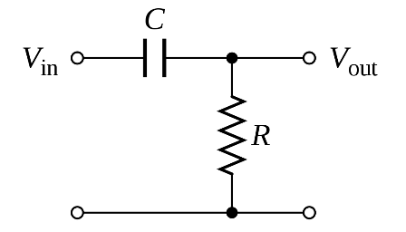
Generally though, you can assume that larger capacitance values for C1, like 10uF, will drop the frequency cut point to a lower frequency, allowing more bass to come through. Dropping the capacitance values to 10nF will raise the frequency cut point to a higher frequency, cutting out more bass frequencies from coming through.

3.2 Emitter Resistance and Input Impedance.
As covered in the Gain Control Mod section, disconnecting the Q1 emitter pin from the PCB and adding an inline potentiometer by connecting the Q1 emitter pin to pins 1 and 2 of the pot and having pin 3 of the pot return to the PCB pad for what was the Q1 emitter pin will also decrease the gain/fuzz of the pedal but increase the input impedance and reduce tone-sucking. Typical potentiometer values are 1K and 5K linear potentiometers. Adding a 22uF or 47uF electrolytic capacitor in parallel to the potentiometer (positive lead on pin 2 of the potentiometer and negative lead on pin 3 of the potentiometer) will also make the fuzz less muddy as the gain is reduced.

4. Volume Control.
The output is controlled by a volume potentiometer that goes to ground, along with an output capacitor to keep any DC current from hopping out of this pedal and into the next (or amp).
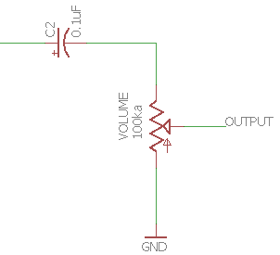
The 100nF C2 output capacitor blocks DC and provides simple high pass filtering. C2 and Volume Pot create a high pass filter.
fc =1 / (2πRC)
fc = 1 / (2π⋅VOLMAX⋅C2)
fc = 1 / (2π⋅100K⋅100nF)
fc = 1 / (2π⋅100,000 ⋅ 0.0000001)
fc = 16Hz
With a cut of 16Hz it will block DC and any low-frequency parasitic oscillation. However, as the volume pot is turned down, resistance to ground is decreased and the filter changes frequency position. For example, if the pot is half way:
fc = 1 / (2π⋅50K⋅100nF)
fc = 1 / (2π⋅50,000 ⋅ 0.0000001)
fc = 32Hz

So, now some of the sub bass frequencies will begin to get cut. A way to resolve this is to increase capacitance of C2 to a 1uF electrolytic or film capacitor.

4.1 Output Impedance.
The pedal output impedance also depends on the volume potentiometer position, being always less than the value of R1 (10K)
- Volume Potentiometer at maximum volume: Zout = 10K parallel to 100K = 9K approx.
- Volume Potentiometer at minimum volume: Zout = 10K parallel to 1K = 0.9K approx.

Ideally, a guitar pedal design aims for low output impedance, it makes the circuit to interact nicely with the rest of the pedals on the board. 9K is not bad; most of the designs keep the output impedance below 1K but 9K is still good.

