7 Min Fuzz Experimenter’s Kit
A short guide to the 7 Min Fuzz
If you are new to pedal building, let me start by saying welcome to an awesome hobby! Included in your Experimenter’s Kit for the 7 Min Fuzz are a range of components you can use to learn about guitar pedal electronics and customize the 7 Min Fuzz to your liking. Personally I find this one of the most exciting parts about building my own guitar effects. I can set things up the way that I like!
I have written these accompanying notes for the 7 Min Fuzz Experimenters Kit to give you a brief understanding of what these components do and how changing these will affect your guitar signal as it passes through the circuit. You should refer to the schematic on the diyguitarpedals website as you read through these notes.
Capacitors
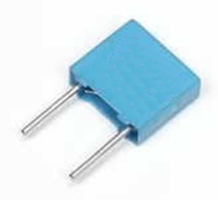
The capacitors at the input and output of the circuit perform two important functions. Firstly, they act as a barrier; preventing the +9v DC voltage that powers the effect from escaping through the input and output of the circuit. We don’t want +9v going into the front of our amps! They also block some of the bass frequencies of the guitar signal at the input and output. Increasing the input and output capacitor values will allow more bass frequencies to pass through the circuit, making for a fuller sounding fuzz!
Sometimes a thinner sound can be more appealing tonally, depending on the circuit and your personal taste. Increasing and decreasing the input and output capacitors can be done on almost every guitar pedal. It is probably one of the easiest modifications possible and has a profound effect on the final output tone of the circuit!
Try it!
Start with 10nf on both the input and output of the circuit. Increase both capacitors to 100nf and notice how the sound now becomes fuller with more low-end response. Also notice how the volume appears to have increased. The signal is now louder because of the added bass content. Try different combinations on the input and output and find what set up you prefer!
Identifying
In order of size, the capacitor values included in your kit are 10nf (nanofarad), 100nf, and 1uf (microfarad). 1uf is equal to 1,000nf. So these capacitors increase greatly in magnitude. The physical markings that identify their capacitance values are:
Value | Markings
10nf | 103 or .01
100nf | 104 or .1
1uf | 105 or 1

Transistor
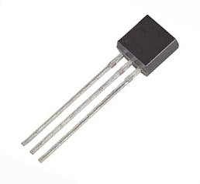
The transistor amplifies your guitar signal, it is the ‘heart’ of the 7 min fuzz. Transistors differ subtly in tone. What has an even bigger impact on the sound of this effect is the transistors gain (“hfe”). There are 4 transistors included in your Experimenters Kit. In order of their gain or “hfe” from lowest to highest they are:

2n3904 (approx. range 100-300 hfe)
2n5088 (approx. range 300-900 hfe)
mpsa18 (approx. range 500-1500 hfe)
mpsa13 (approx. range 5,000-10,000 hfe)
Increasing the gain of the transistor creates a fuzzier distortion. In this circuit, increasing the gain will also misbias the circuit. A misbiased fuzz sounds ‘gated’ and ‘splatty’. This can be a desirable effect, some people prefer their fuzz effects misbiased.
Identifying
Look closely or use a magnifying glass to read the markings and identify which transistor is which. Follow the outline of the transistor on the silkscreen image printed on the PCB when inserting the transistor and ensure it is inserted correctly. All the transistors included in the 7 Min Fuzz have the same pinout, so they are all inserted into the circuit in the same orientation.
Resistors
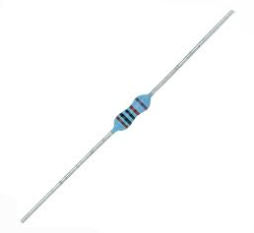
In order to negate the effects of changing the transistor type and gain and consequentially misbiasing of the 7 Min Fuzz, a range of resistor values have been included for you to be able to adjust the bias accordingly. Notice the sound change as you add a higher and lower resistor values. You can deliberately misbias your 7 Min Fuzz if you prefer the sound! Also try replacing the diode with a 1meg resistor, this will turn the 7 Min Fuzz into a clean boost!
Identifying
You can use a multimeter to measure the resistance value of a resistor. If you don’t have a multimeter handy you can work out the resistance from a resistor colour code chart or have a look online for a “4 band” or “5 band” resistor calculator that will work out the resistance value for you.

Diodes
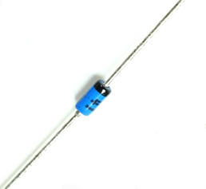
Diodes are often used on the output of a guitar pedal to clip a clean or already distorted guitar signal (tubescreamer, distortion+, for example). However, the diode in the 7 min fuzz contributes to biasing the transistor as well as clipping your guitar signal and adds its own flavour to the final tone. It is critical in the operation of the effect which would not work if left out or inserted backwards. The band on a diode indicates the cathode or negative of the diode. Make sure to match this band with the 7 Min Fuzz silkscreen (white printing on the pcb surface “D1”). Any diode can be used with the 7 Min Fuzz and there are MANY available. Be careful when handling and bending the leads of diodes as they are often encapsulated in glass and can / will crack or break.
The diodes included in your experimenter’s kit are:
1n914
Color: Orange/red
Very common small signal silicon diode
1n34a
Color: Clear Glass
A Germanium diode (yep that’s right, the stuff in the germanium transistors used in fuzz pedals of old!)
Bat41
Color: Blue
Small Signal schottky Diode (my personal favourite).
Identifying
Most diodes will have their part numbers printed on their surface. The diodes included in the Experimenters Kit are different colours which makes identifying them easy. The colors of each are listed above.
And don’t throw away any of the remaining components you have left over from your experimenters kit! All of the components included in the kit are very common and can be used for building other pedals!
I hope you have enjoyed this brief tour of building guitar effects and thank you for supporting my webstore and youtube channel!
Paul Punturere
diyguitarpedals.com.au

7 Min Fuzz
Experimenters Kit


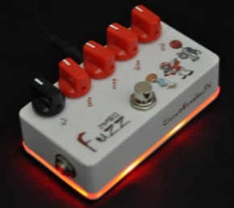
diyguitarpedals.com.au

