

7 Min Fuzz
The 7 min fuzz is a low part count high-gain circuit that produces a very respectable, thick sounding fuzz tone. However this is just one of the sounds capable from this circuit. It is quite adaptable and if you have purchased the experimenters kit you can follow along with my basic notes on how to tweak it! The BOM below lists the ‘standard’ configuration (thick sounding fuzz).
Bill of materials
Resistors | Diode
R1 10k | D1 BAT41 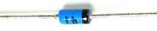
Capacitors | Transistor
C1 1uf (105) 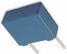 | U1 MPSA13 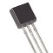
C2 100nf (104)
 | Potentiometer
 | Volume 100ka Log 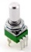
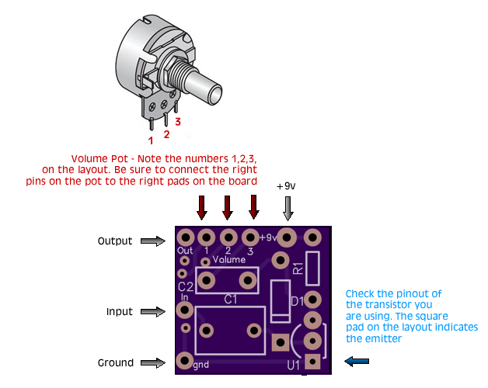

Orientation and Polarity of the Components

Polarity of the BAT41 Diode
Note the polarity of the BAT41 diode. The Band on the diode must match up with the band printed on the circuit board:

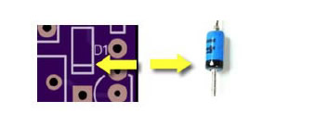

Orientation of the MPSA13 Transistor
The Transistor must also be installed into the circuit the correct way around. Note the image of the transistor printed
onto the circuit board. This must be matched with the shape of the body of the transistor



Orientation of the resistor and capacitors
The resistors and capacitors (film) are not polarised and can be inserted into the circuit board either way

Reference Designators
The reference designator (the letter followed by a number found on the bill of materials, see picture below) identifies the component of an electrical schematic. This Reference Designator (“refdes” for short) also appears on the silkscreened printing on the circuit board. See below an example of the reference designator for R1, a 10k resistor, found on the bill of materials and the printed circuit board. So for R1, we would solder a 10k resistor into this position.
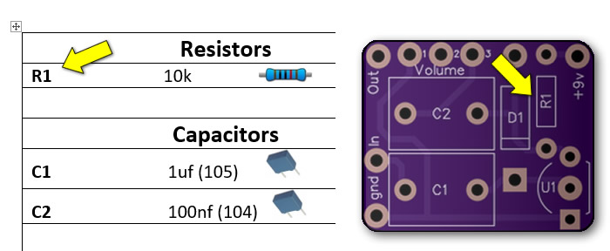

7 Min Fuzz – Bass Guitar Mod
The Capacitors included in the 7 Min Fuzz Kits are selected for electric guitar, however the circuit will work with bass guitar as well with only a small modification; higher value capacitors on the input and output, C1 and C2 (available on the webstore). Film capacitors in values above 1uf are quite expensive, so it’s typical to use electrolytics in their place. Electrolytic capacitors in values between 1uf and 10uf would be suitable for experimentation.

Electrolytic capacitors are polarized, one lead is negative the other positive. The positive lead should be connected to the ‘more positive’ side of the circuit. I have marked the positive pads with red crosses on the picture of the PCB below for your convenience:
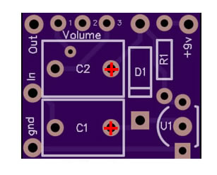

7 Min Fuzz – Gain Control Mod
Adding resistance to the emitter of the 7 min fuzz transistor will reduce the gain of the circuit. We can add a modification for adjusting the gain of the effect by adding a potentiometer to the circuit, a device that increases resistance as you turn the dial.
Check out the wiring diagram below for a visual representation of how to go about adding this gain control and also my video on how to add a Gain control the 7 min fuzz circuit:
(youtube link)

https://www.youtube.com/watch?v=WCFrhkL1a2I

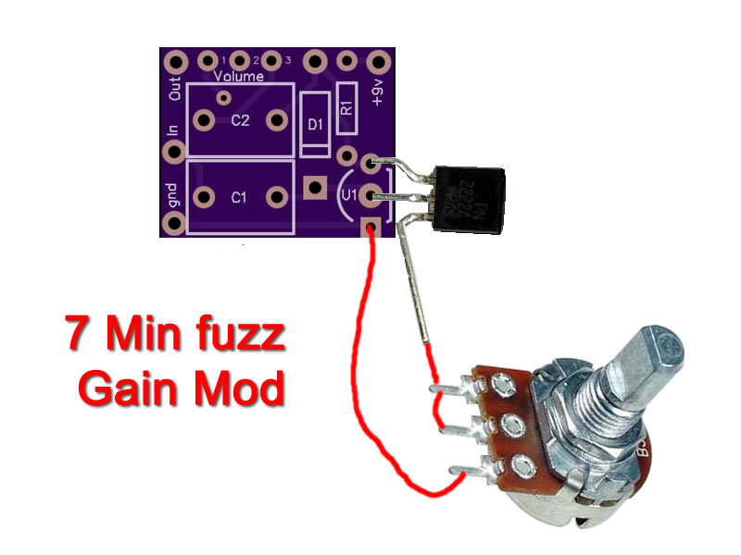

Tip for soldering 9mm Alpha Pots

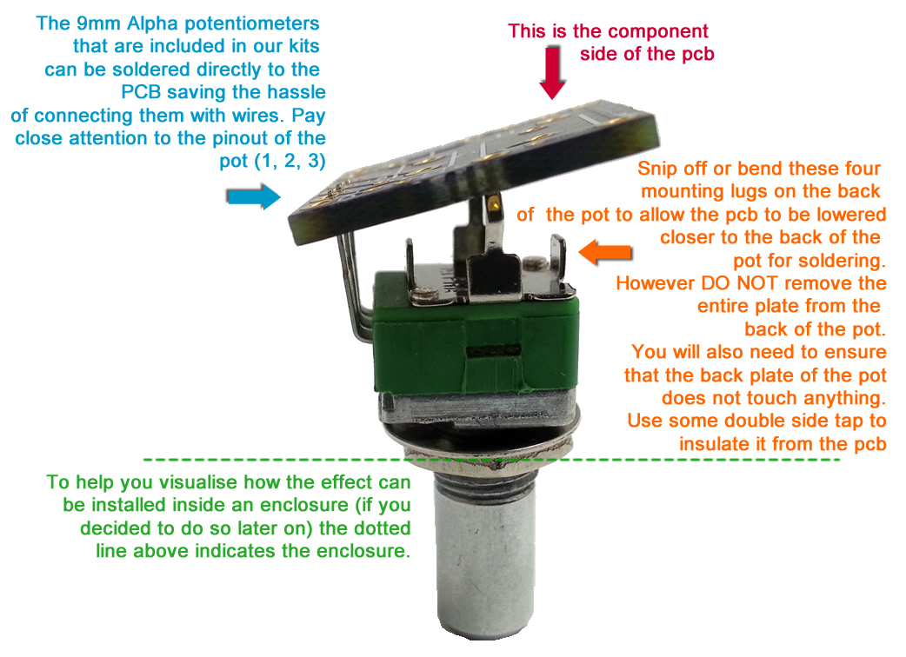

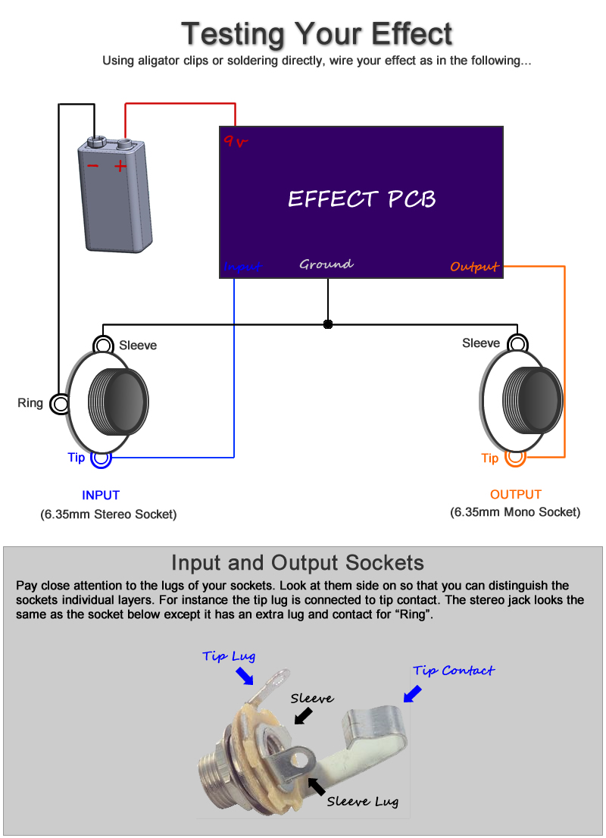

Note, you can still test your effect with 2 mono jacks, just combine the negative of the battery with the ground input sleeve connection. A DC Jack will also work for a power source, replace the battery above with a dc jack.

Offboard Wiring Diagram
Using a non-switched Miniature DC Jacks and 2 Mono Jacks (kit option with diyguitarpedal kits)

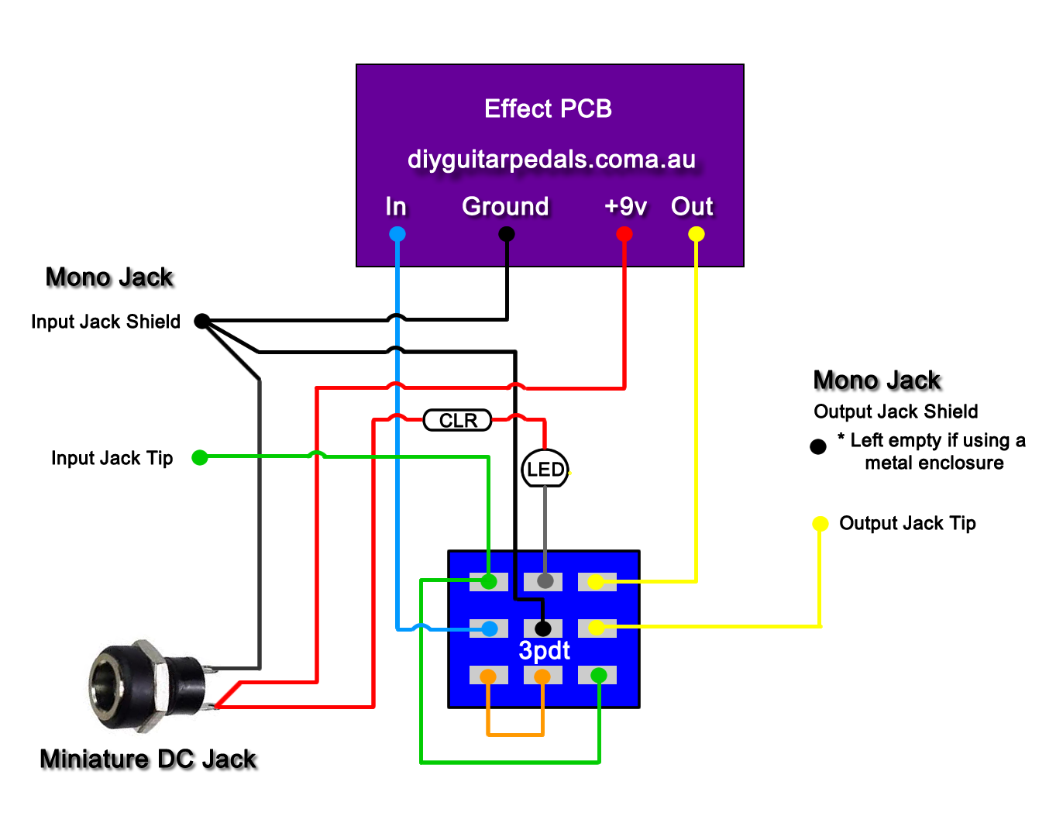
“CLR” = Current Limit Resistor. This resistor (included with your LED and bezel controls the brightness of the led and stops the LED from blowing. Also note the flat side of the LED, examine your LED closely you will note it physically has a flat side. This is the negative side of the led as pictured above
The Lugs of the Miniature DC Jack
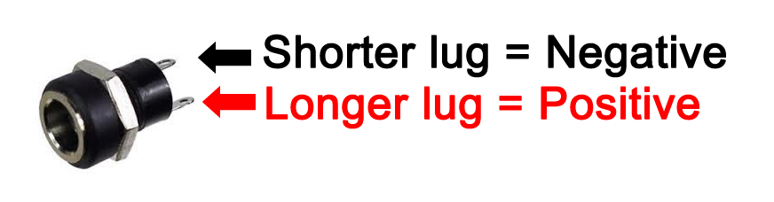
The miniature dc jacks that are sold as a kit option with pcbs have 2 lugs, 1 short and 1 long and should be connected as shown in the picture to the right. To confirm which lug is which, sight done the socket hole, you should be able to see which lug is connected to the pin and which is connected to the barrel of the jack. Also note that miniature dc jacks do not allow for battery switching, they can only be used for DC power.

Wiring up the LED and Current Limiting Resistor (CLR)
Follow these steps to assemble a pedal status LED using an ‘extruded’ led:
- Identify the positive and negative lead on the LED (Long lead = Positive, Short Lead = Negative)
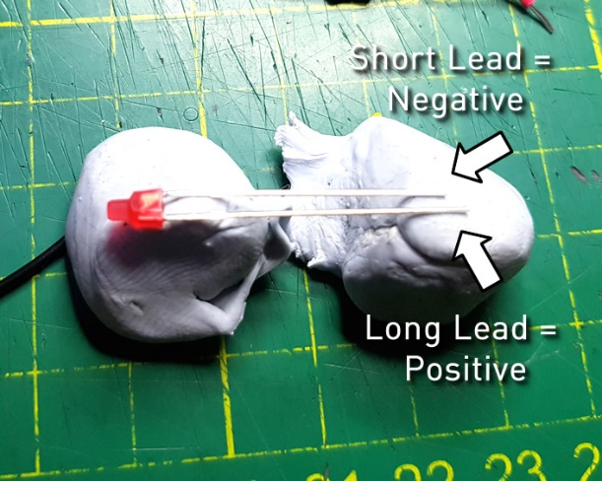

- Snip one the resistor leads (5-8mm length) and the positive led lead and line both leads up so they are parallel and solder in place
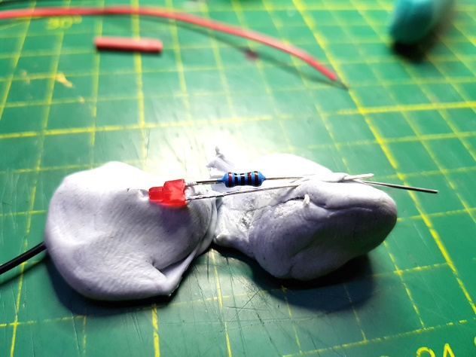

- Snip the other lead of the resistor and solder the positive / red wire to the lead

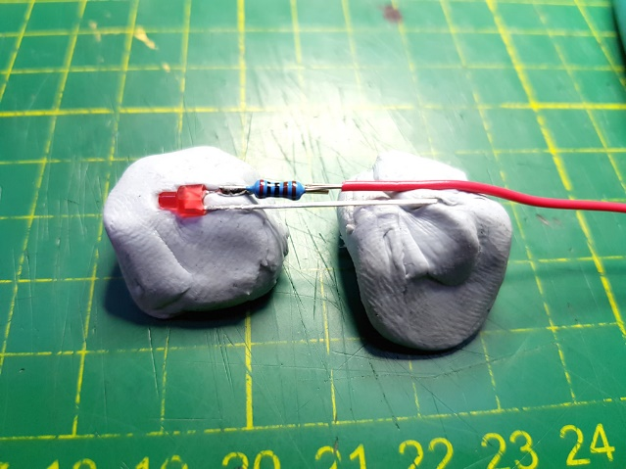

- Snip the other LED lead as before and solder the negative / black wire to it.
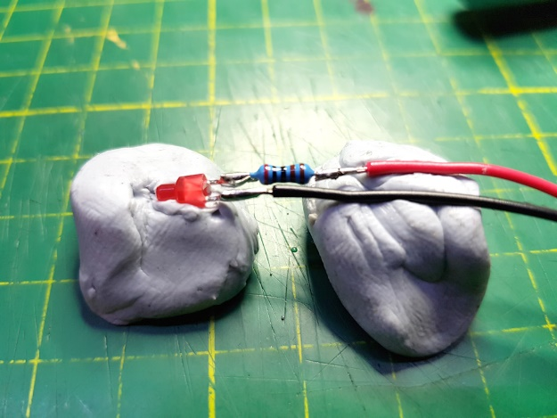

- The cover the exposed solder joints and resistor, cut 2 lengths of heat shrink and place over the exposed joints / resistor.
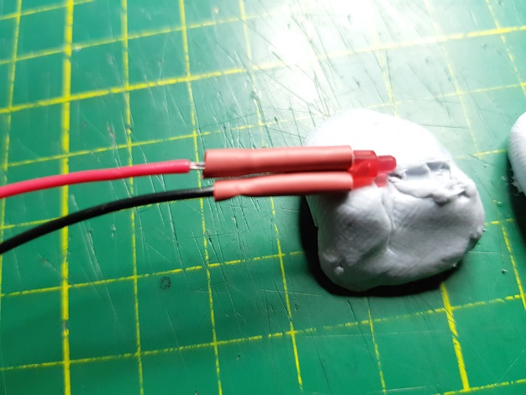

- Using the heat from your soldering iron, shrink the heat shrink in place. This will help prevent the two leads touching each other and creating an electrical short.
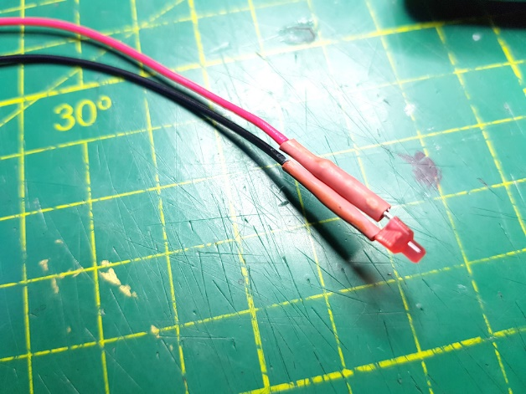

- Test the LED with a 9v battery. (do not test an LED with a 9v battery if the current limiting resistor is not in place as this will blow the LED).

