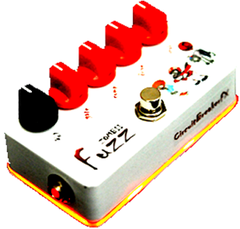
diyguitarpedals.com.au

7 Min Fuzz

diyguitarpedals.com.au

7 Min Fuzz

diyguitarpedals.com.au

7 Min Fuzz

