

Big Knob
What do you get when a One Knob Fuzz collides with a Big Muff Pi Tone Stack? Ok, minds out of the gutter…The Big Knob of course! I’ve always felt the One Knob Fuzz could use a tone control for versatility as well as experimentation. The Big Muff Pi won the deal, it marries seamlessly with the One Knob Fuzzes expressive output. 16mm pot spacing and silicon transistors make this project a good contender for a silicon fuzz with “bang for buck”.

Bill of materials
Resistors | Capacitors
R1 1M | C1 100nf
R2 10k | C2 220pf
R3 82R (see notes) | C3 10nf
R4 2k2 | C4 10uf
R5 150k | C5 22nf
R6 1k | C6 220nf
R7 39k | C7 220nf
R8 47k
R9 430k | Transistors
R10 100k | Q1 2n3904 (see notes)
R11 15k | Q2 2n3904 (see notes)
R12 3k3 | Q3 2n5088
Potentiometer | Diodes
Volume 100ka (16mm) | D1 1n4001
Tone 100kb (16mm)

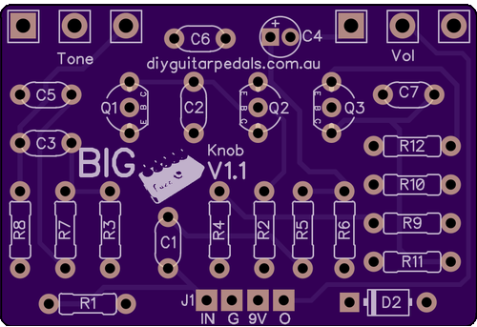

PCB Spacing
The Big Knob PCB is spaced for 1590B sized enclosures or larger

Pot Spacing
The Big Knob’s pcb mounted potentiometers are spaced for Alpha 16mm potentiometers.

Modifications
Following is a couple of worthwhile modifications that I discovered expermenting with the Big Knob

Transistors
This ones obvious. Q1 and Q2 form the gain stages of this silicon fuzz. Increasing and decreasing the gains of these transistors will effect the tonal character of the fuzz. In my experimentation a lot of NPN’s sounded good, I personally perferred the S9013’s though (available on my store) as they are relatively low gain. To intention mismatch gains (like a lot of fuzzes have), a 2n3904 in Q1 and a higher gain transistor in Q2 may increase sustain of the effect. The original circuit used BC107 and BC108 for Q1 and Q2 respectively, these can still be sourced. Q3 is the recovery stage of the big muff and wont have much effect on tone shaping.

R3
For most settings the Big Muff Tone Stack should be at unity or greater. However as the big muff pi is so reknowned for sucking the volume out of your signal you could consider socketing R3 and increasing its value for more output volume. Resistor R3 controls the voltage to the collector of Q2 as well as the lpb1 style recovery stage booster on the output. Replacing this resistor with a higher value can have an effect on the biasing of the circuit. A 1k trimpot could be used for adjustment. Be warned a significant volume increase will occur when the trimpot is cranked.

Shopping List
Although I do not stock all components you will need for the Big Knob, a lot of what you need can be found on my store.
The remaining parts you will need are an enclosure (1590b), A 3pdt footswitch, led and current limit resistor and bezel and any other aesthetic additions you choose.

Click on the value to go to the webstore page:

Big Knob V1.1 – Shopping List
Resistors | Capacitors
R1 1M | C1 100nf
R2 10k | C2 220pf
R3 82R or 1K Trimmer (see notes) | C3 10nf
R4 2k2 | C4 10uf
R5 150k | C5 22nf
R6 1k | C6 220nf
R7 39k | C7 220nf
R8 47k
R9 430k | Transistors
R10 100k | Q1 2n3904 or S9013 (see notes)
R11 15k | Q2 2n3904 or S9013 (see notes)
R12 3k3 | Q3 2n5088
Hardware (for DC power Only) | Diodes
Mini Mono Jack x 2 | D1 1n4001
Compact DC jack - Economy
All knobs on my page will fit spacing
Wire

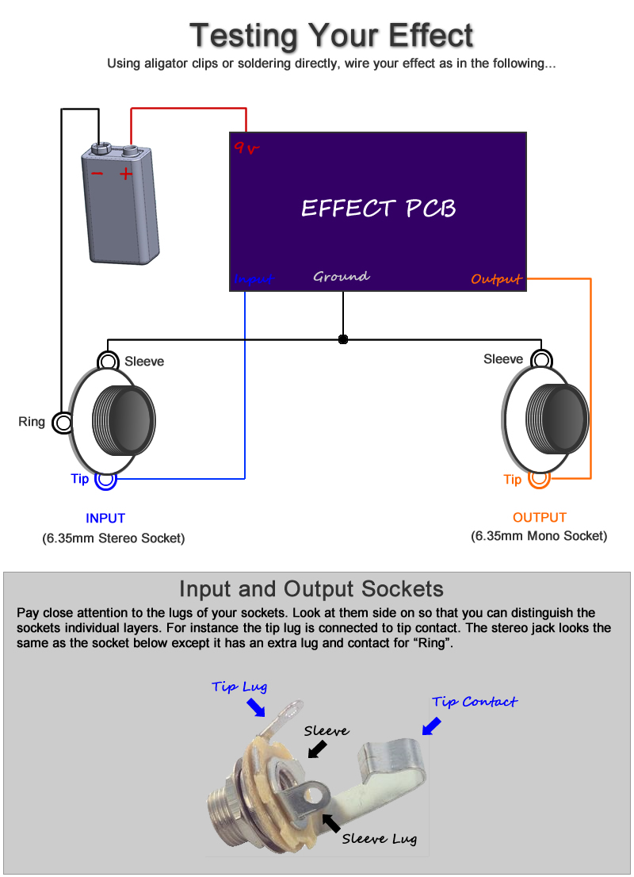

Offboard Wiring Diagram
Using a non-switched Miniature DC Jacks and 2 Mono Jacks

