

Big Knob
What do you get when a One Knob collides with a Big Muff? Ok Ok, let’s keep this adult. It’s going to be difficult but I’ll try.
The Big Knob is based on the Colorsound One Knob Fuzz, a very well balanced and articulate silicon fuzz. I’ve always thought a big improvement to this effect would be some sort of tone control to shape the sound of the output. The Big Muff Tone Control stack seemed like the obvious choice and after much experimenting has proved to marry very well with this fuzz circuit.

Bill of materials
Resistors | Transistors
R1 1M | Q1 BC109
R2 10k | (any low gain silicon – 2n3904, s9013, etc)
R3 82R | Q2 BC108
R4 2.2k | (any low gain silicon – 2n3904, s9013, etc)
R5 150k | Q3 2N5088
R6 1k
R7 39k | Capacitors
R8 47k | C1 1uf (105)
R9 430k | C2 220pf
R10 100k | C3 10nf
R11 15k | C4 10uf
R12 3.3k | C5 22nf
 | C6 220nf
Potentiometer | C7 220nf
Volume 100ka (Logarithmic)
Tone 100kb (linear) | Diode
 | D1 1n4001

Notes for assembly
Transistors
The BC transistors were used in the original units. These can still be sourced but are somewhat expensive. In truth a lot of low gain NPN silicon transistors will sound good in this circuit. A few to try are 2n3904, S9013, PN2222A, etc. Socket these 2 transistors and experiment. Q3 is part of the big muff tone control recovering stage and does not need to be changed.

82R Resistor
Replacing this resistor with a 1k trimmer may act a bit like a bias control (confirmed)

430k resistor
This resistor is an odd value, I have it stock on my webstore (stock before release). If you have trouble sourcing it, replace it with a 390k, this will have little effect on the biasing of the big muff recovery stage or solder a 390k and 39k resistor in series will get you in the ballpark.

Tip for soldering 9mm Alpha Pots

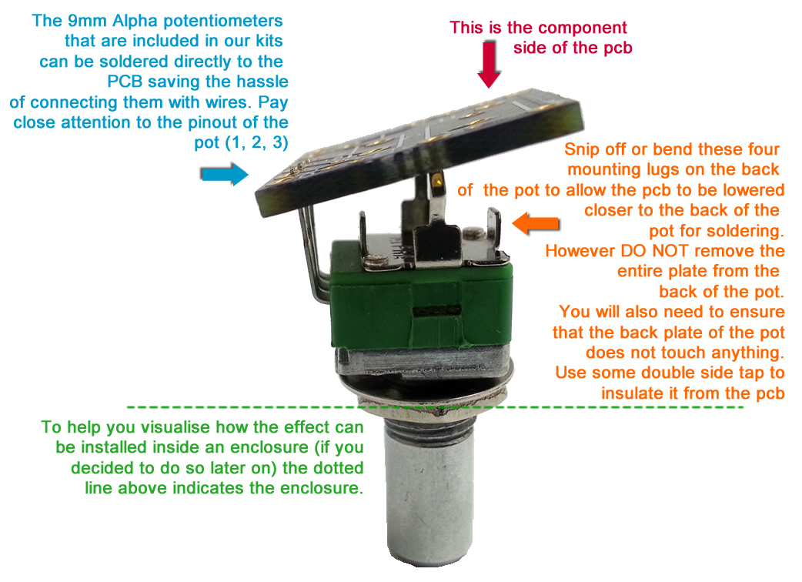

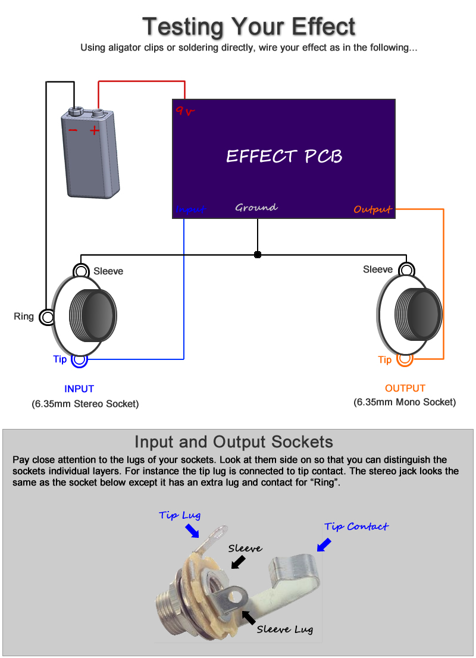

Note, you can still test your effect with 2 mono jacks, just combine the negative of the battery with the ground input sleeve connection.

Offboard Wiring Diagram
Using a non-switched Miniature DC Jacks and 2 Mono Jacks (kit option with diyguitarpedal kits)

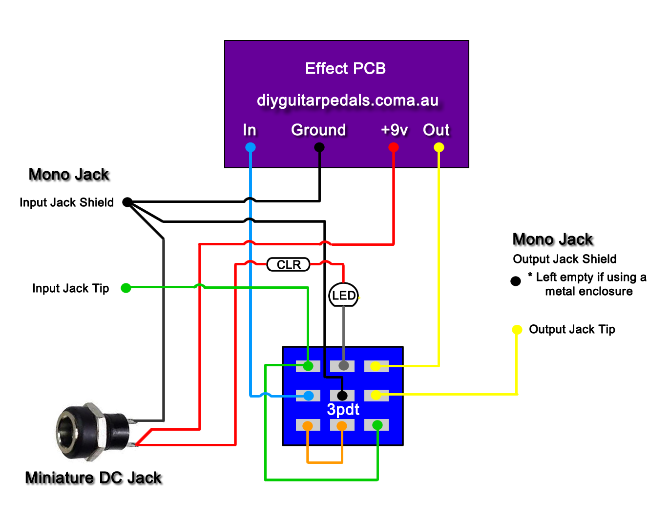
The Lugs of the Miniature DC Jack

The miniature dc jacks that are sold as a kit option with pcbs have 2 lugs, 1 short and 1 long and should be connected as shown in the picture to the right. To confirm which lug is which, sight done the socket hole, you should be able to see which lug is connected to the pin and which is connected to the barrel of the jack. Also note that miniature dc jacks do not allow for battery switching, they can only be used for DC power.

