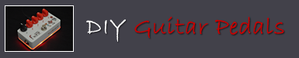

SMD Practice LPB1 Boost
Based on the EHX LPB1 (linear Power Boost) this dirty boost is a great introduction to smt soldering.
The resulting effect is very small (“boost on a dime”) and could fit into some of the tightest of spaces.

Bill of materials
Resistors | Capacitors
R1 1M | C1 100nf (104)
R2 1M | C2 100nf (104)
R3 10k
R4 100k | Diodes
R5 390R | D1 1n4001
IC | Potentiometer
U1 BC847/849 | Volume 100ka

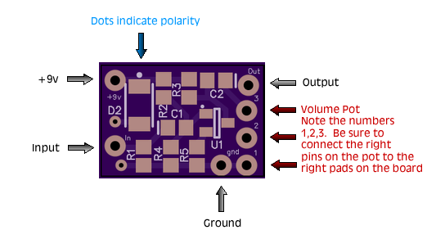

Tip for soldering 9mm Alpha Pots

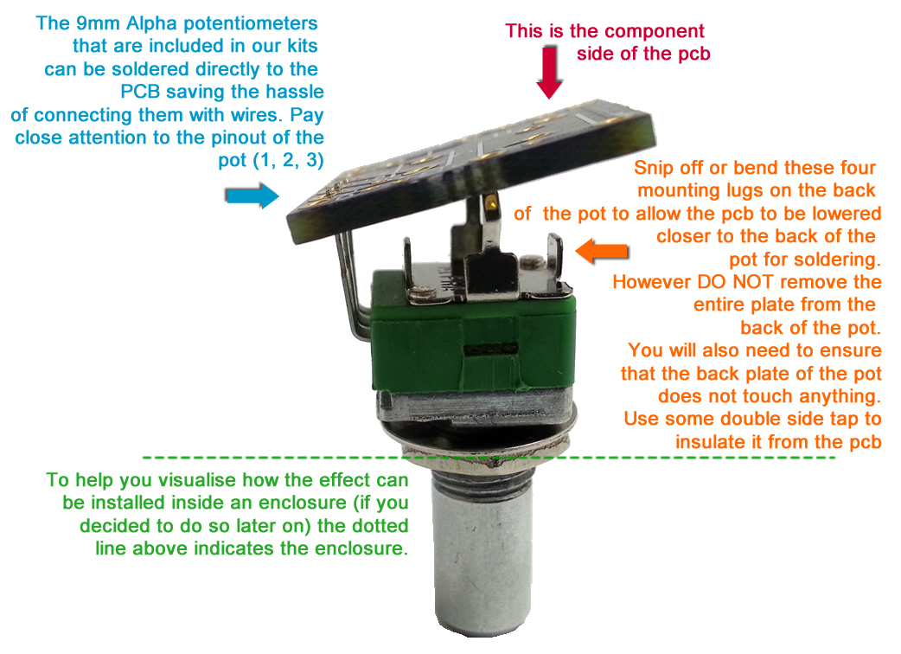

SMD LPB1 Kit Notes

Identifying the Components

Capacitors
2 x Beige Colored chips. These are the 2 x 100nf in/out caps. Non-polarized.

Transistor
The black thing with three legs :D Only fits the board one way around.

Diode
The 1n4001 is the largest of the chips. Black with a M1 and a white stripe printed on top (white stripe indicates polarity)

Resistors
The value is printed on top of the chip. If you have trouble reading them use a magnifying glass or jewelers loop. The values are read as such:
Examples
1003 = 100 (and 3 more zeros) = 100,000 = 100k.
8201 = 820 (and 1 more zero) = 8200 = 8.2k
3900 = 390 (and no more zeros) = 390 = 390. NOT 3900

A couple of SMD Soldering Tips

For an in-depth tutorial on smd soldering watch a few videos on youtube, but for a “no-fuss” method of SMD soldering, read my tips below:
- 1) When removing the chip from the packaging, do it inside a container or contained area, so there is less chance of losing the chip if you accidentally fling it. Remember if it hits the carpet, it’s usually impossible to find
- 2) Apply flux to the pads then place the component down. The flux will help prevent the chip from ‘tombstoning’
- 3) (When using flux) Apply small amount of solder to the iron, then bring the solder to the component. Because there is flux on the component already the solder on the iron tip will still flow. Only use 0.3m solder. Trust me, it’s much easier to control.
  - 4) Use blutac to hold the board still on your workbench as demonstrated in my video here. This will make your SMD soldering experience 1000x easier: http://www.youtube.com/watch?v=C4ACT2w93Mc

I hope you like the experience of SMD soldering and the kit, if you have any problems /questions please message me through the store

Paul Punturere
www.diyguitarpedals.com.au

