Classic  BOOST  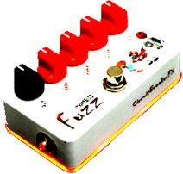  diyguitarpedals.com.au | (Please go to our website for  bill of materials and build instructions)
Classic  BOOST  diyguitarpedals.com.au | (Please go to our website for  bill of materials and build instructions)

