

Ember Drive
Based on the Emdrive™, The Ember Drive is a simple low part count overdrive / fuzz that really packs a punch! The input volume control (the “Gain” control) of the original circuit has been replaced with a Tone Control which I find to be more versatile. Changing the transistor of the Ember Drive can result in signal clipping from overdrive to more of a fuzz tone (see mod below).

Bill of materials
Resistors | Diode
R1 4K7 | D1 1n4001
R2 2M2
R4 1meg | Transistor
 | U1 MPSA13 / 2n5088
Capacitors | Potentiometer
C1 100nf (104) | Volume 250ka Log
C2 10nf (103) | Tone 100kb Lin
C3 100nf (104)

1590a
The board spacing will fit a 1590a enclosure. You can mount 9mm pots directly to the pcb.
Tone mod
Changing the values of c1 and c2 will change the frequency range of the Tone Control. Also note c3 will affect the bass output of the circuit as well (increase for more bass, decrease for less). I’ve found the best combination for this set up is as listed above.

Transistor Mod
Try changing the transistor to an MPSA13 for thicker, fuzzier sound! (An mpsa13 and sockets are included with the component kit).
Youtube Link: DIYGP Ember Drive Transistor Comparison

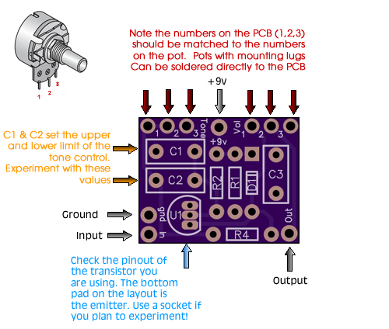

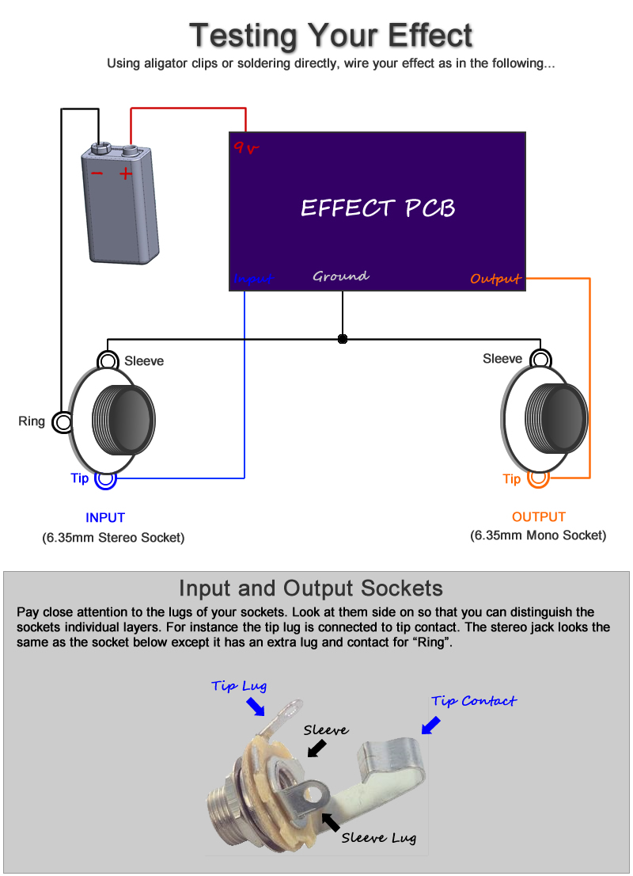

Note, you can still test your effect with 2 mono jacks, just combine the negative of the battery with the ground input sleeve connection.
Offboard Wiring Diagram
Using a non-switched Miniature DC Jacks and 2 Mono Jacks (kit option with diyguitarpedal kits)

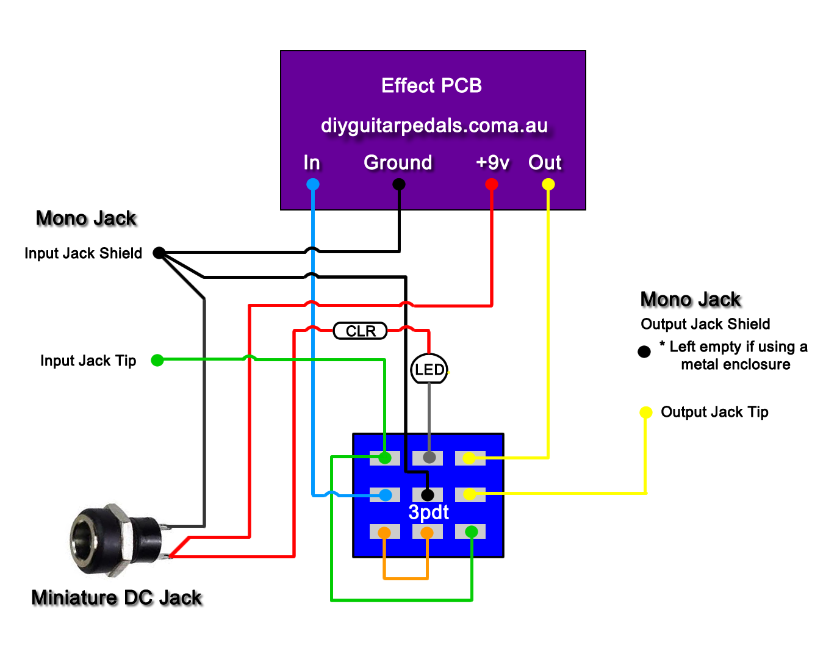
The Lugs of the Miniature DC Jack
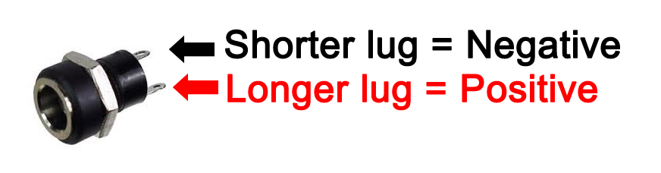
The miniature dc jacks that are sold as a kit option with pcbs have 2 lugs, 1 short and 1 long and should be connected as shown in the picture to the right. To confirm which lug is which, sight done the socket hole, you should be able to see which lug is connected to the pin and which is connected to the barrel of the jack. Also note that miniature dc jacks do not allow for battery switching, they can only be used for DC power.

