

FaceMaster
Based on the Dallas-Arbiter Fuzz Face™

Bill of materials
Resistors | Diode
R1 100k | D1 1n4001
R2 33k
R3 470R | Transistor
R4 200R | U1 Germanium Transistor
R5 1 Meg | U2 Germanium Transistor
Capacitors | Potentiometer
C1 100nf (104) | Volume 500ka Log
C2 10nf (103) | Tone 100kb Lin
C3 20uf | Fuzz 1ka Log
C4 10uf | Bias 20k (trimmer)
C5 100uf
C6 10uf | IC
C7 100nf (104) | IC1 Charge Pump (TC1044scpa)

1590a
The board spacing will fit a 1590a enclosure. You can mount 9mm pots directly to the board.

Gain Pot
The original fuzz face used a 1kb pot. This causes the fuzz effect to ‘bunch up’ towards the end of the dial turn. Use a reverse log pot (“C”) to avoid this. Also, a 2k pot may be better suited to increase the fuzz range (more fuzz).
Tone mod
Changing the values of c1 and c2 will change the frequency range of the Tone Control. Also note c3 will affect the bass output of the circuit as well (increase for more bass, decrease for less). I’ve found the best combination for this set up is as listed above but you increase c1 and decrease c2 for a wider range or vice versa for a narrower tone range.

Bias Trimmer
Experiment with the value of this trimmer. Depending on your germanium transistors used a 50k trimmer may be better suited. You can also mount this as a pot on the front of your pedal for an external bias control

Charge Pump
This layout includes the 9v power inverter and associated components for your convenience.

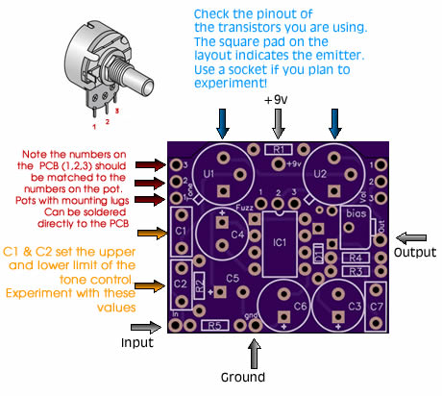

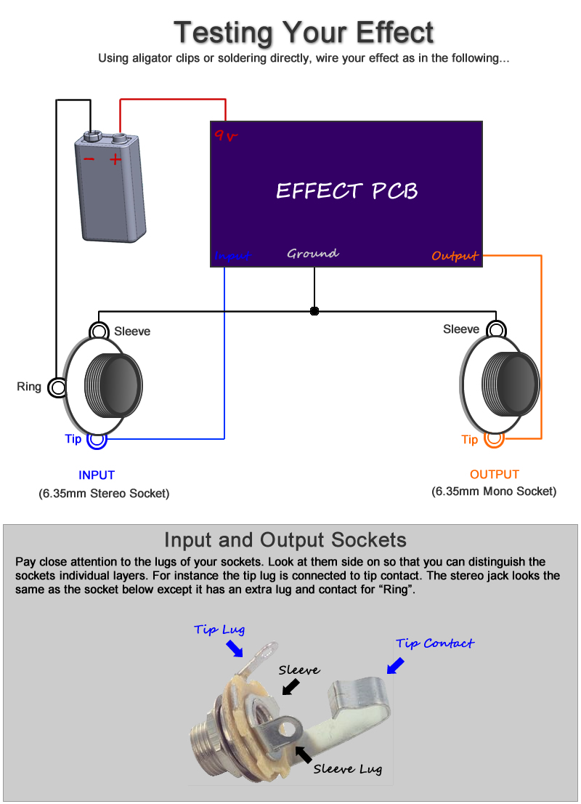
Boxing up your effect

Watch my offboard wiring tutorial for information on wiring this effect up inside an enclosure (with LED, stompswitch, etc)

http://www.youtube.com/watch?v=z6fpwU8RY_0

