

Hydra Fuzz
Based on the Sola Sound Tonebender™ 3-knob

Bill of materials
Resistors | Capacitors
R1 1M | C1 22uf
R2 47K | C2 100nf (104)
R3 220K | C3 220pf
R4 10K | C4 100nf (104)
R5 10K | C5 10uf
R6 3.3K | C6 100nf (104)
R7 10k | C7 2.2nf (222)
R8 18k (or Trim) | C8 10uf
R9 10k | C9 100uf
R10 10k
R11 220k (or Jumper) | Transistor
 | Q1 PNP Germanium Transistor
Diode | Q2 PNP Germanium Transistor
D1 1n4001 | Q3 PNP Germanium Transistor
D2 1n270
 | Potentiometer
IC | Volume 100KB Lin
IC1 Charge Pump (TC1044scpa) | Tone 100KB Lin
 | Fuzz 100KB Lin

1590b
The board spacing will fit a 1590b enclosure. You can mount 9mm pots directly to the board.

Pot Tapers
Pot tapers of the original Sola Sound Tonebender™ used all linear potentiometers, even for the volume control. I would definitely recommend a log pot for the volume control to avoid bunching.

Bias Mod
Replace the 18k resistor with a 50k trim to dial in some splatty misbiased fuzz sounds with your Hyrda Fuzz! Wire in a pot instead for an easily adjustable bias control.

R11
Replacing R11 with a jumper will allow more output volume from the effect

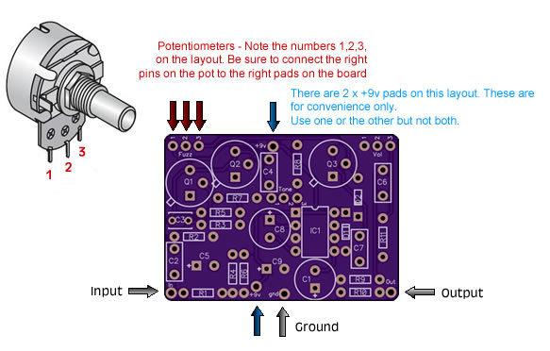

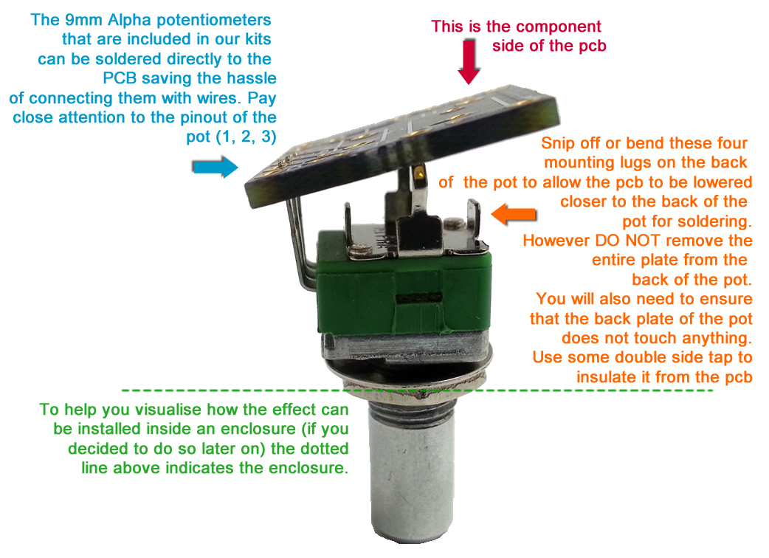

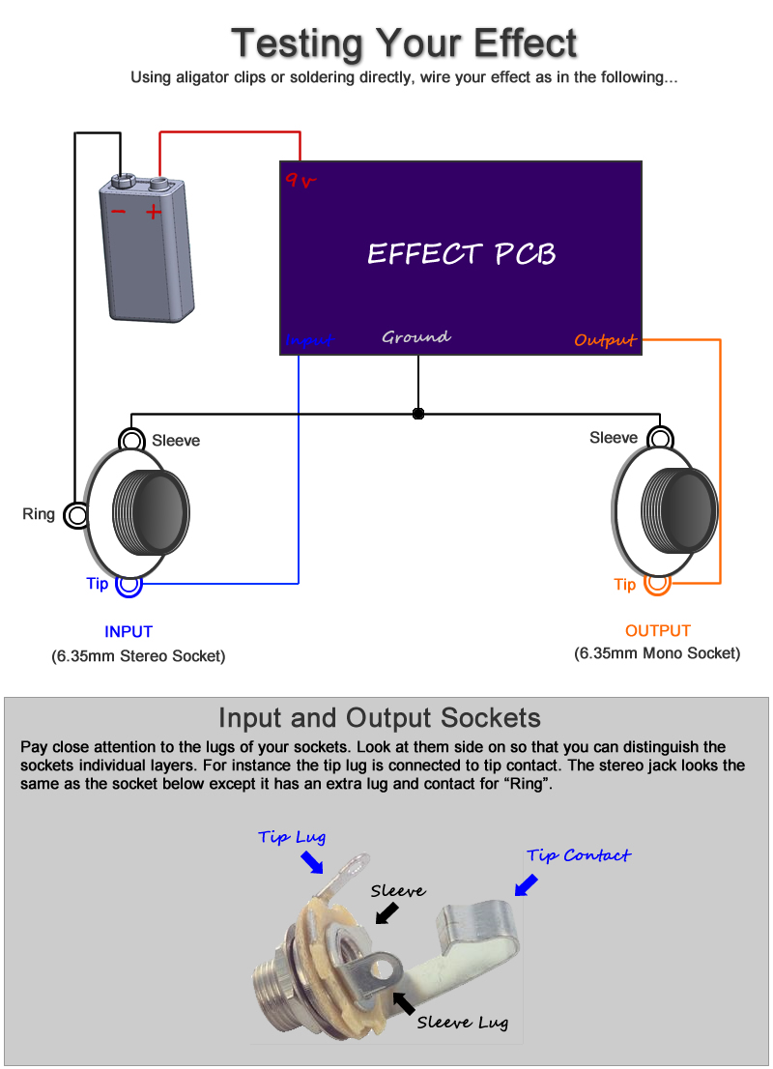
Boxing up your effect

Watch my offboard wiring tutorial for information on wiring this effect inside an enclosure with LED, stompswitch, etc

http://www.youtube.com/watch?v=z6fpwU8RY_0

