NightDrive  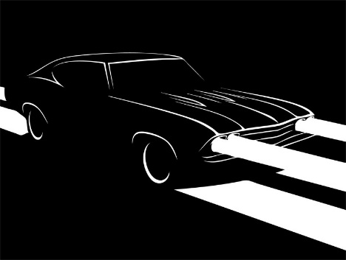  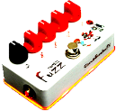  diyguitarpedals.com.au | (Please visit our website for  bill of materials and build instructions)  http://www.diyguitarpedals.com.au/shop/kits  All Kits Proudly Assembled in Australia
NightDrive  diyguitarpedals.com.au | (Please visit our website for  bill of materials and build instructions)  http://www.diyguitarpedals.com.au/shop/kits  All Kits Proudly Assembled in Australia

