smtBOOST    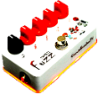  diyguitarpedals.com.au | (Please go to our website for  bill of materials and build instructions)
smtBOOST  diyguitarpedals.com.au | (Please go to our website for  bill of materials and build instructions)

