How to assemble and program the Smart ByPass Module
Part I: WinAVR Installation.
- Go to https://sourceforge.net/projects/winavr/ and download the latest WinAVR to get the avrdude tools. Once downloaded, double-click on the install file. If prompted, press Yes.
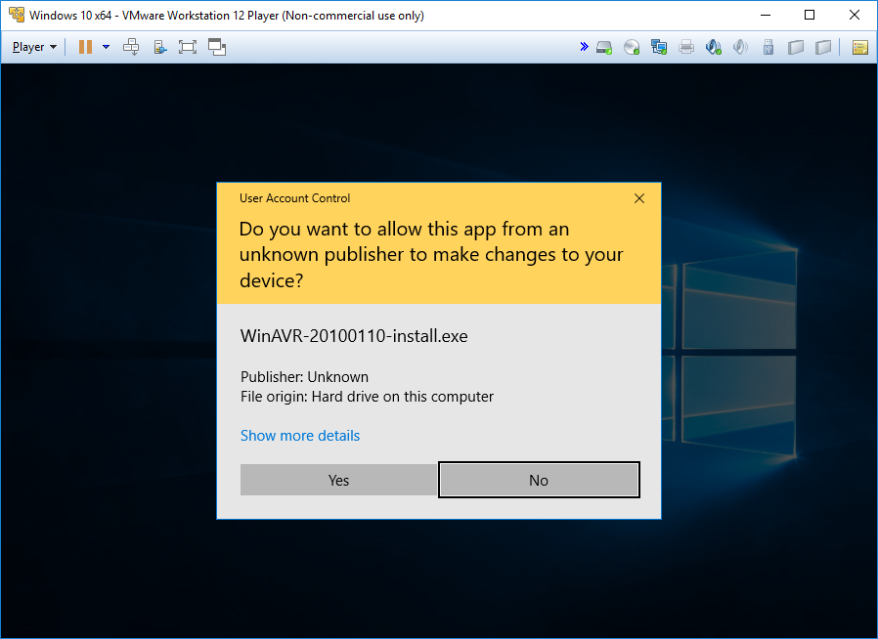

- Select the language and press OK.
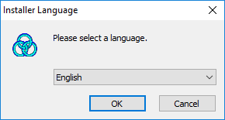
- Press Next
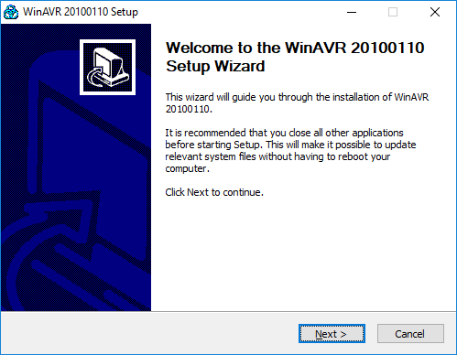
- Select I Agree.
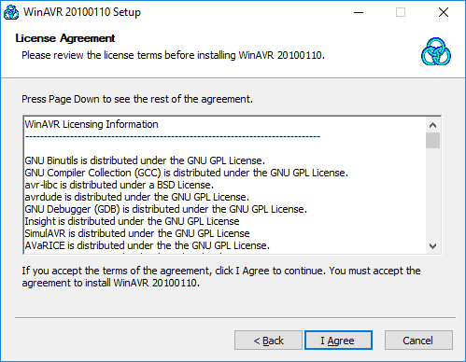
- Press Next.
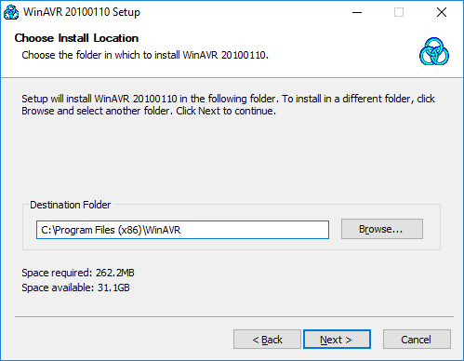

- Press Next
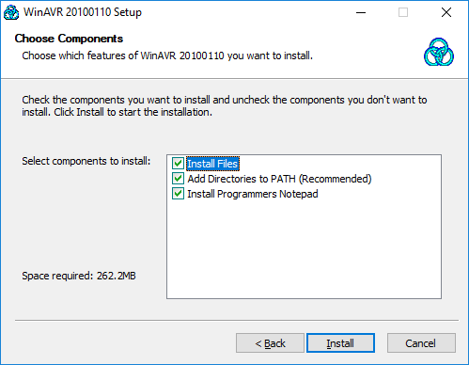

- After it installs the files completely, press Finish
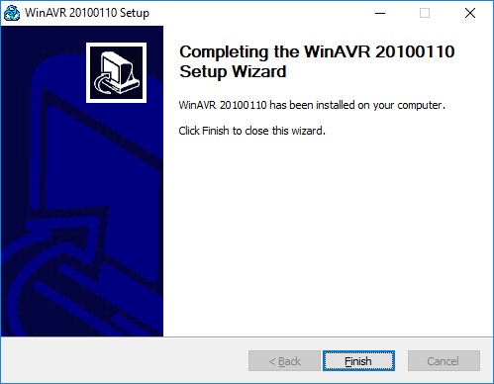

Part II: Programmer Installation.
- Go to Sparkfun’s site here: https://www.sparkfun.com/products/11801. Purchase this programmer as it can do most 8-Pin Atmel microcontrollers, including the attiny13a. Once received, drivers will need to be installed. DO NOT PLUG IN DEVICE YET. Go to site and select documents on the lower right and then select “USBTinyISP Driver”.
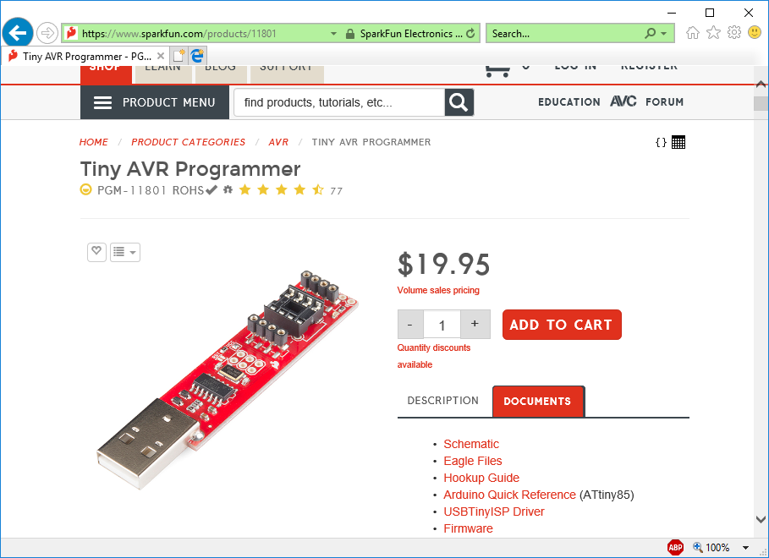

- Once the drivers are downloaded, right click on the saved file and select Extract All
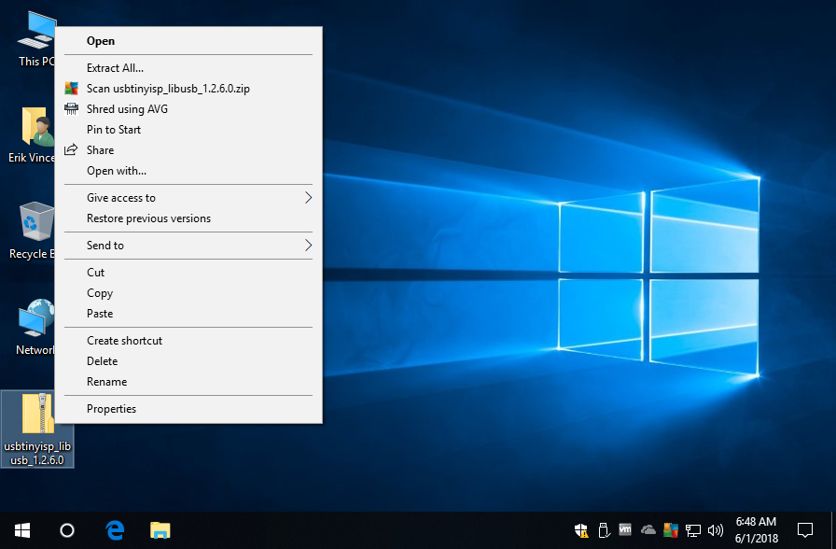

- Press Extract
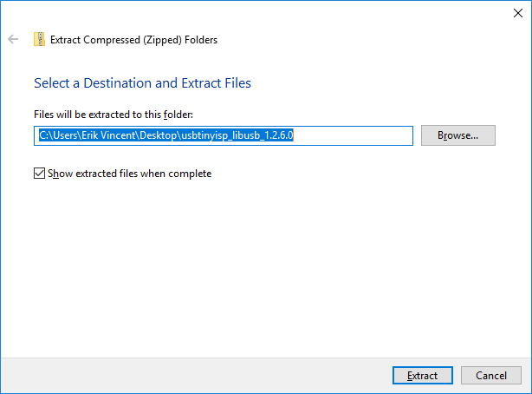

- Make sure Always trust software from “Adafruit Industries” is checked and press Install
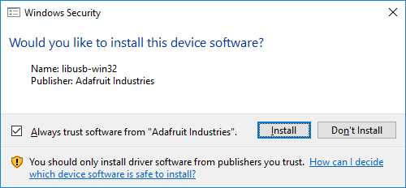

- Press OK.
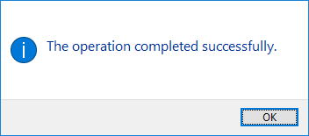

- Plug your attiny13a into your programmer. Make sure notch matches markings on microcontroller. Then plug into PC.
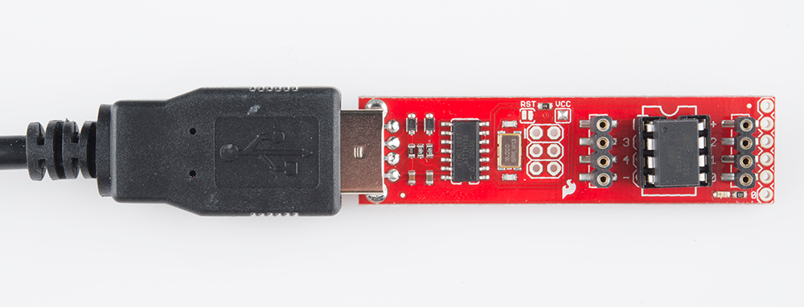

- Press the Windows Key and R to bring up the run box. Type in cmd and press OK.
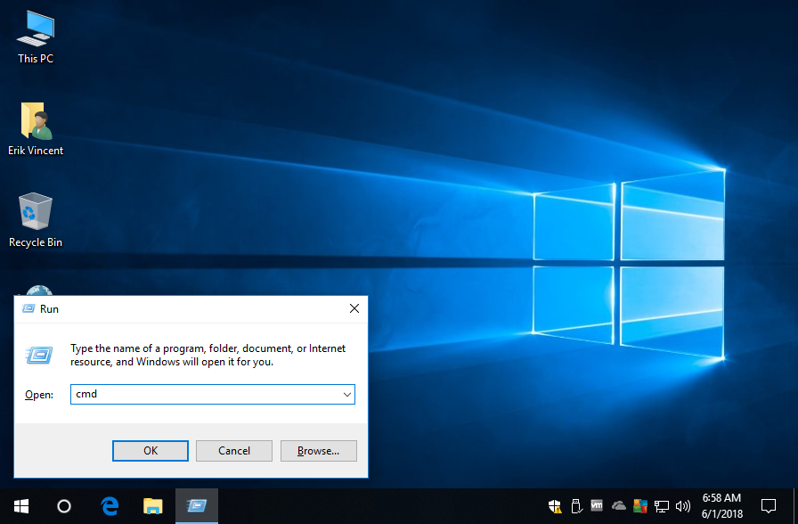

- This will bring up a DOS box
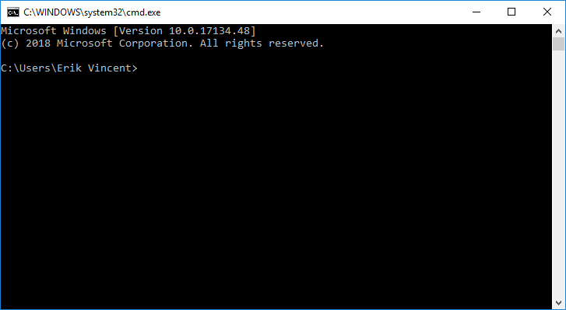

- Type in avrdude -c usbtiny -p t13 and then press OK. If everything is ok, one should see things like what is below.
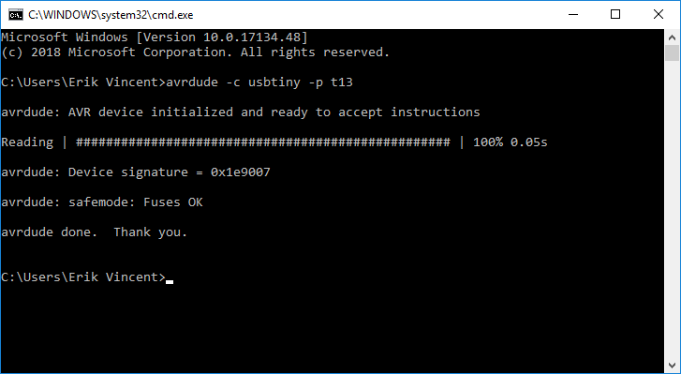

Part III: Programming the chip.
- From a DOS prompt, if the below commands worked successfully, we can install the hex file firmware to the microcontroller. Download the smartbybass.hex file the desktop
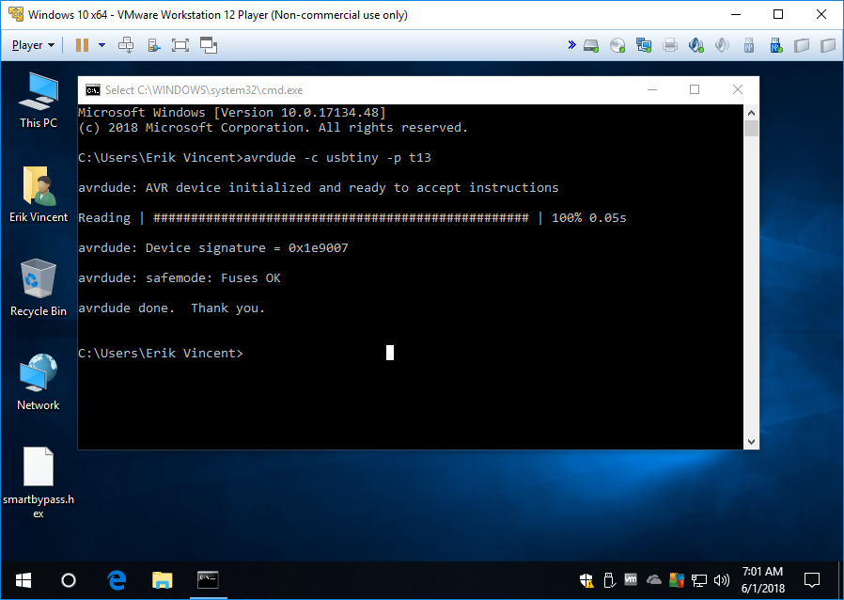

- Next type in cd Desktop and press Enter to change directory to the Desktop
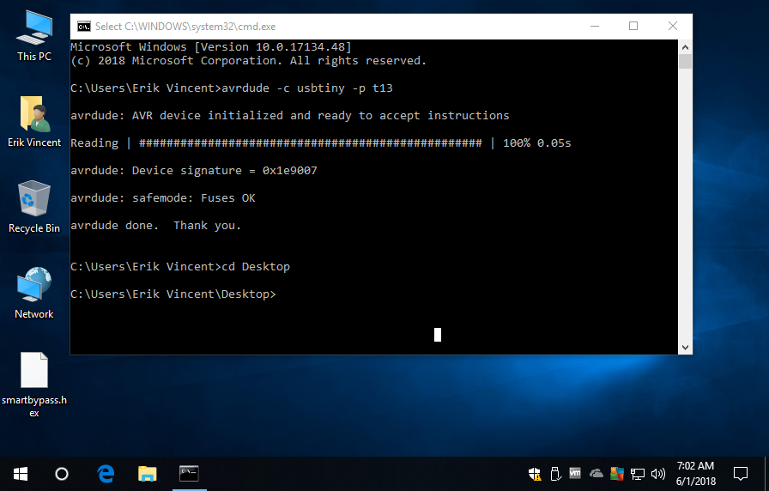
- Type in avrdude -c usbtiny -p t13 -U flash:w:smartbypass.hex and press enter.
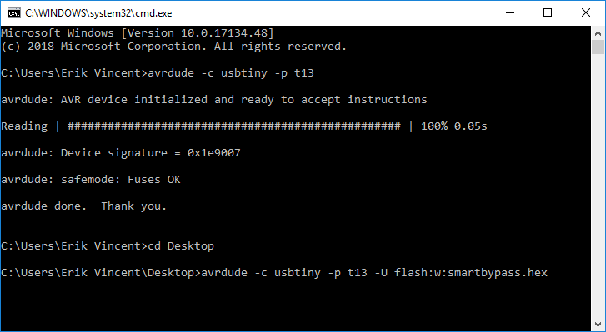

- The chip will begin to program. It should only take a couple seconds. Once it states it is done, that is it. The chip is programmed. Remove from the USB Programmer.
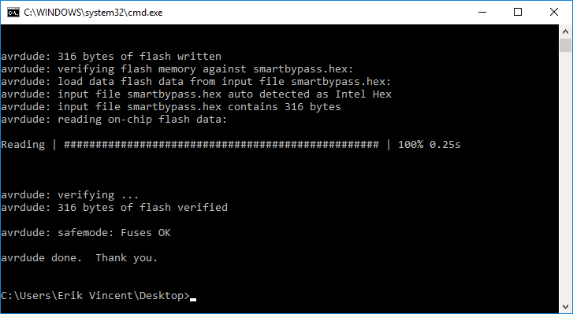

Part IV: Assembly.
- This is the top of the Smart ByPass PCB.
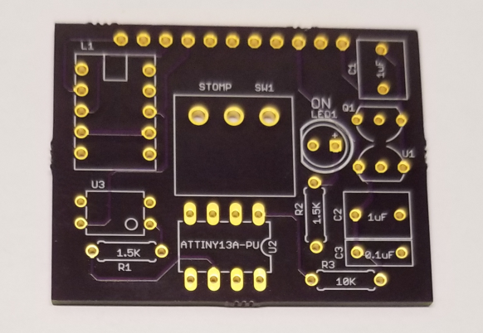

- This is the bottom of the PCB. Note the J1 Header
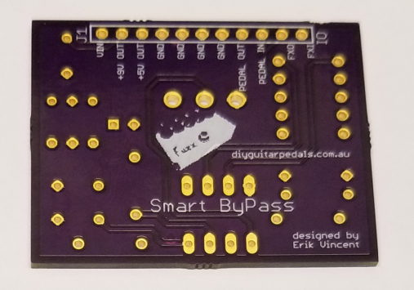

- First, solder the 1/4W resistors. The values for R1 and R2 are 1.5K. The value or R3 is 10K.
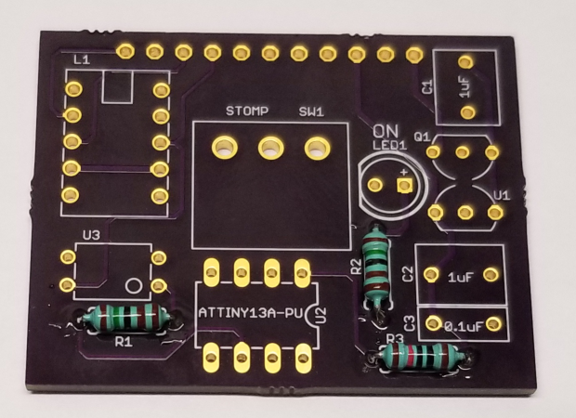

- Next, solder the P-Channel MOSFET, Q1.
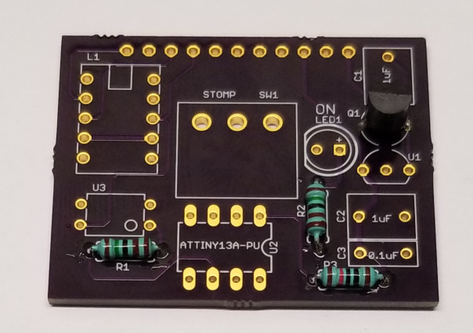

- Next, solder the 5V Regulator, U1.
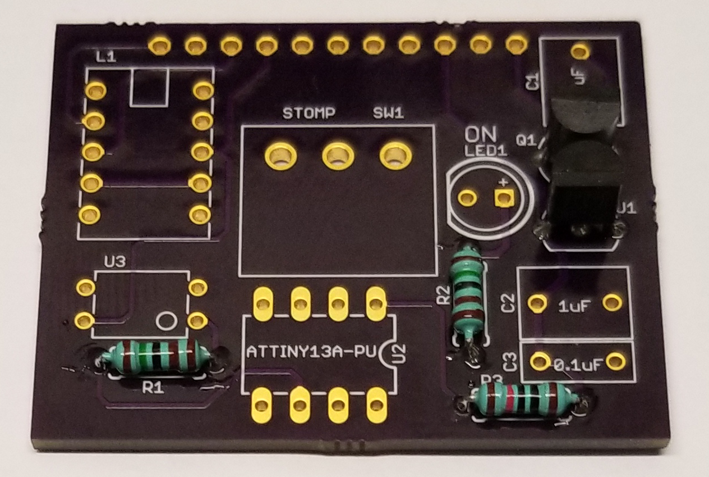

- Next, solder the 8-Pin socket onto U2. Let Bono and the Edge know.
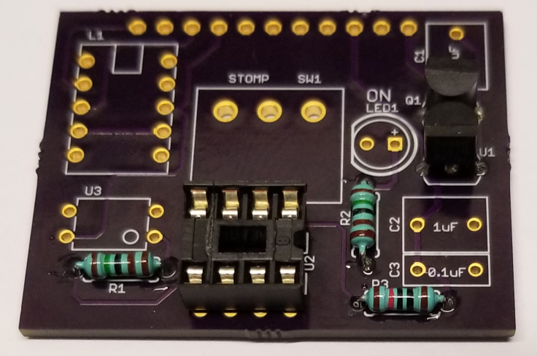

- Next, solder the solid-state relay, U3
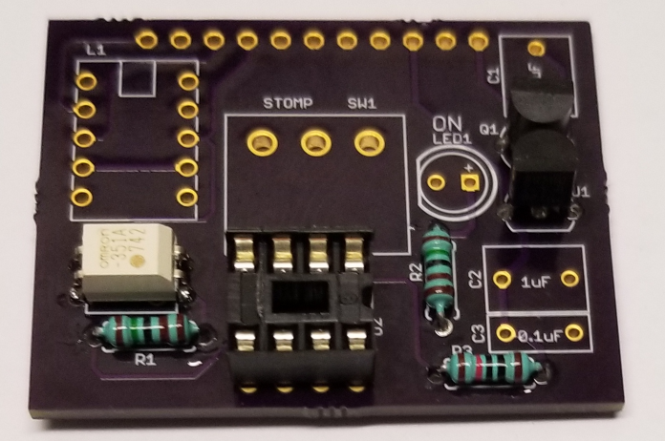

- Next, solder the small current latching relay, L1
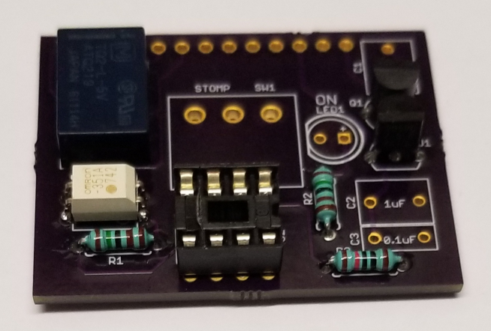

- Next, solder the film capacitors, first with C3, then C1 and C2. The values of C1 and C2 are 1uF. The value of C3 is 0.1uF
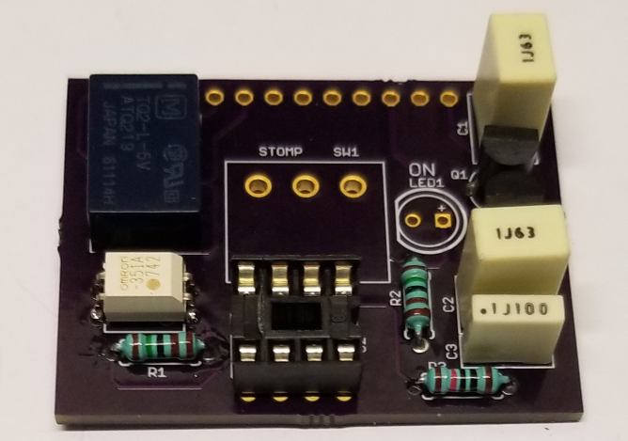

- Next, solder up the stomp switch to SW1
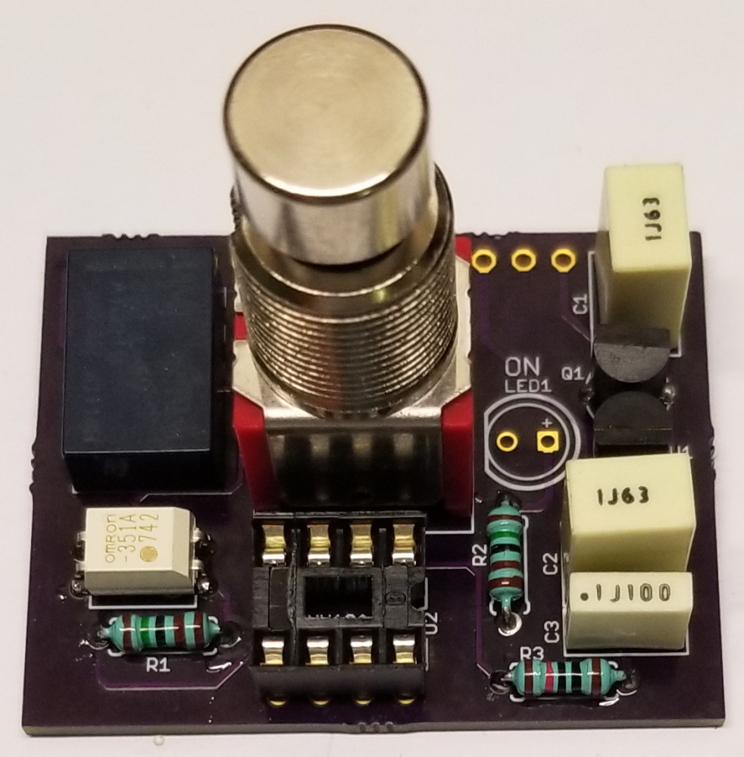

- Next, solder the LED to LED1. It should stand off a little bit as to get it closer to where the stomp switch will be flush-mounted to the box of the pedal.
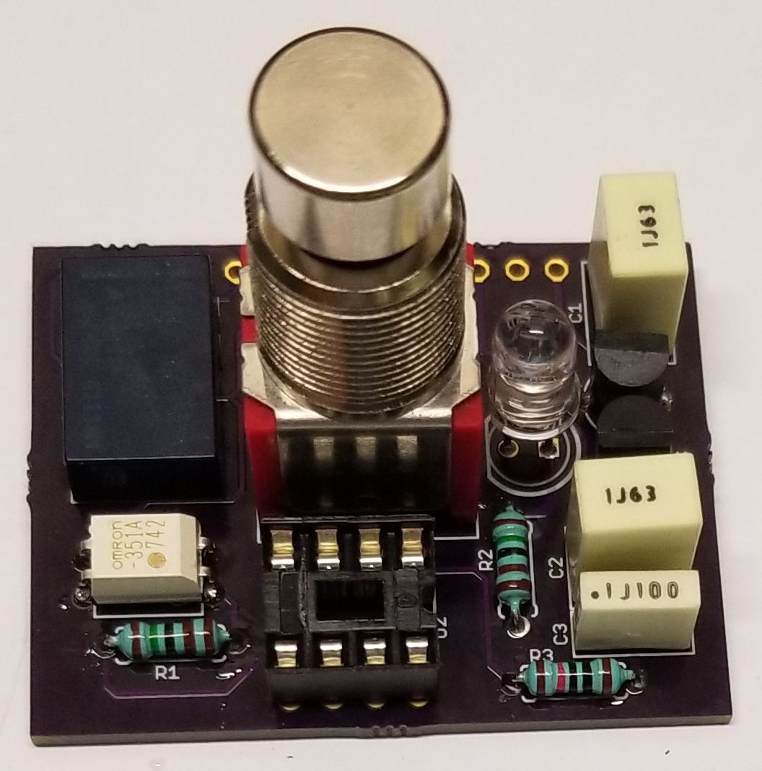

- Next, insert the programmed microcontroller. Make sure the markings are correct.
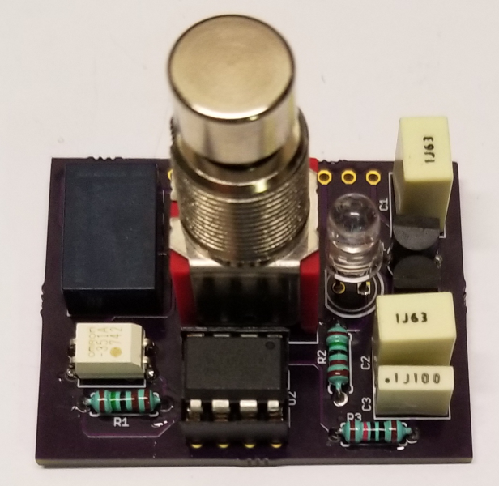

- Flip over to the bottom and note J1 and it’s labels.
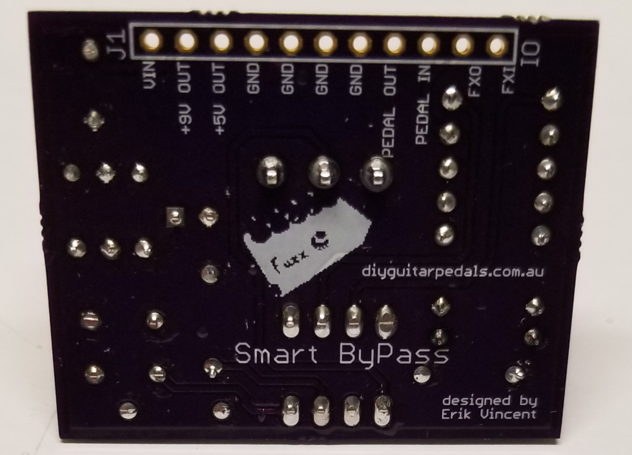
VIN – 9V coming in from battery or wall power
+9V OUT – protected 9V power. This connects to your effect board to provide it 9V power
+5V OUT – protected 5V power up to 100mA. This goes to your effect board if it needs 5V power
GND – this is for common ground components such as power ground, input/output jack ground, and effect board ground. Note, not all grounds may be utilized.
PEDAL OUT – this connects to the output jack’s output signal wire
PEDAL IN – this connects to the input jack’s input signal wire
FXO – this connects to the effect board’s output
FXI – this connects to the effect board’s input

