

Smart ByPass
Design By Erik Vincent

Reliable, Durable, Regulated. The Smart ByPass has been designed with a “smart” preprogrammed ATTINY chip at its core and covers almost everything you could want in a bypass solution. This kit comes with everything you need (see BOM below) to build the Smart ByPass, including a preprogrammed chip, making its construction for you simply a matter of soldering. Some of the many features of the Smart ByPass include:
- Reliable non-latching SPDT stomp E-Switch (rated at 30,000 cycles)
- Reliability of a relay bypass solution (analogue latching relay)
- Regulated (power filtered) 5v output
- Smarter reverse polarity protection for your pedals using PFETs instead of diodes
- Kit includes Preprogrammed attiny13a and all parts for easy assembly including the footswitch!
- The state of the relay is held for ~1/2 a second if power is disconnected. This is to prevent slight power interruptions that would otherwise cause the Smart Bypass relay to switch to bypassed mode.

Bill of materials
Relay | Capacitor
L1 TQ2-L-5V | C1 1uf (film)
 | C2 1uf (film)
Stomp Switch | C3 100nf (film)
Mini Non-Latching SPDT Stomp Switch
IC | Transistor
U1 LP2950-50LPRE3 (68MR7CE) | Q1 VP2106N3-G
U2 ATTINY13A-PU
U3 G3VM-351A | Resistor
 | R1 1k5
LED | R2 1k5 (LED CLR)
LED1 5mm Status LED | R3 10k

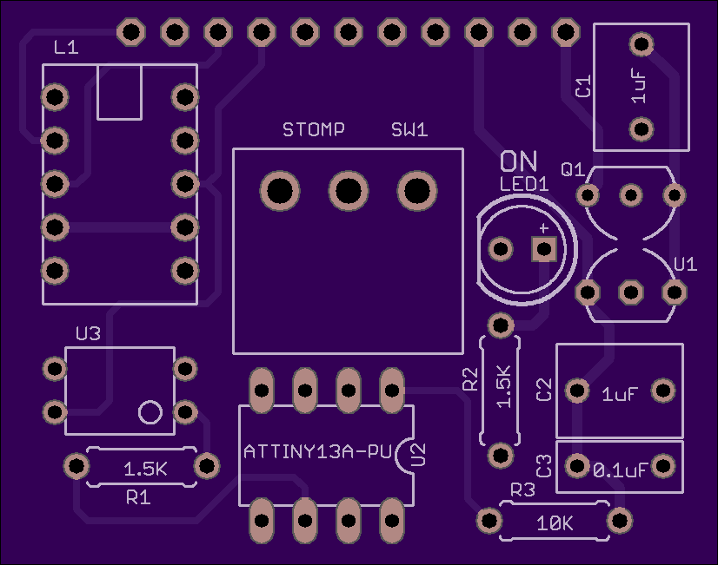

Assembly / Soldering
- This is the top of the Smart ByPass PCB.
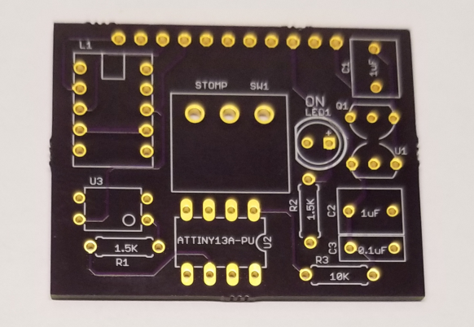

- This is the bottom of the PCB. Note the J1 Header
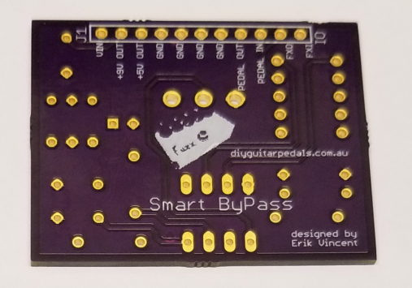

- First, solder the 1/4W resistors. The values for R1 and R2 are 1.5K. The value or R3 is 10K.
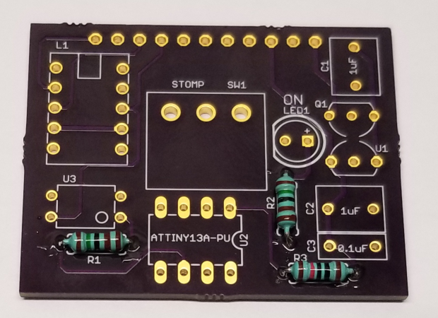

- Next, solder the P-Channel MOSFET, Q1.
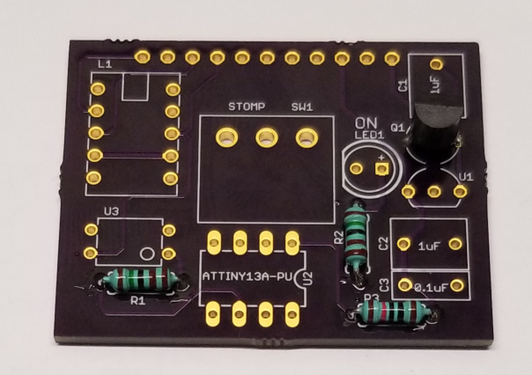

- Next, solder the 5V Regulator, U1.
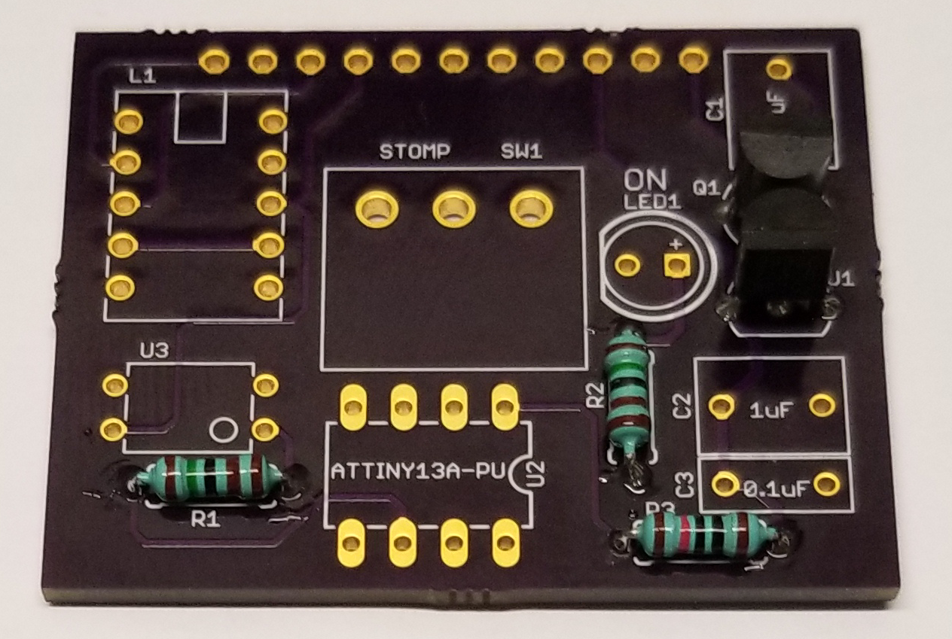

- Next, solder the 8-Pin socket onto U2. Let Bono and the Edge know.
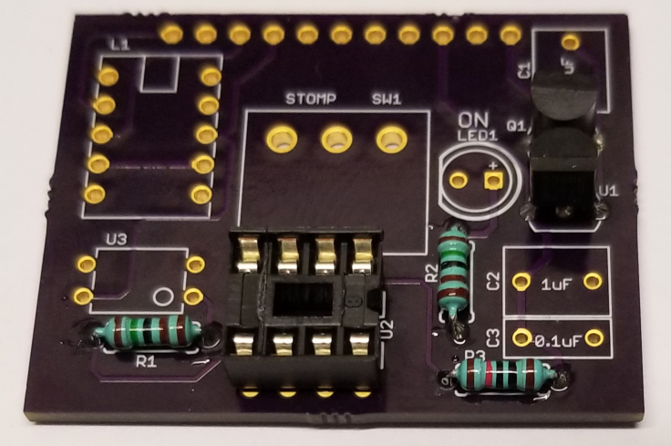

- Next, solder the solid-state relay, U3
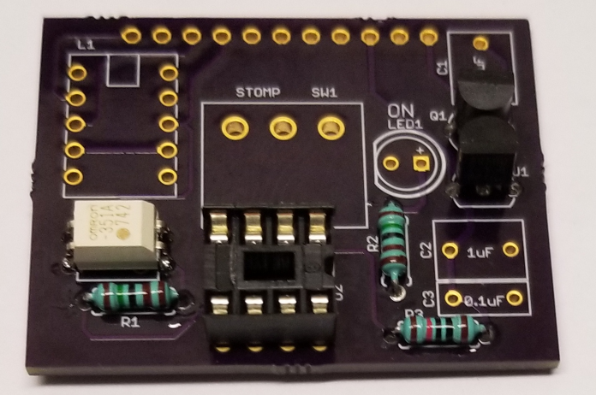

- Next, solder the small current latching relay, L1
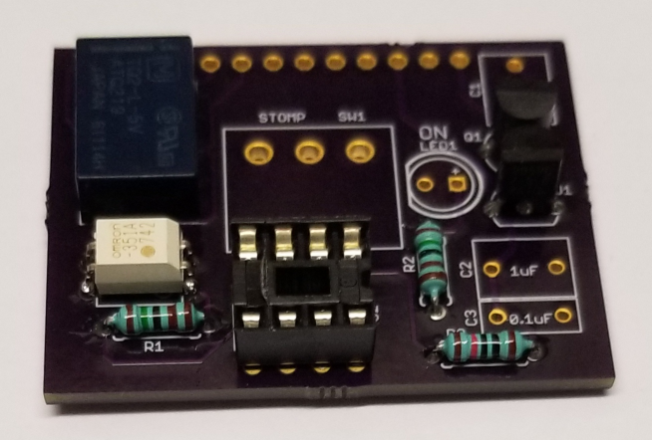

- Next, solder the film capacitors, first with C3, then C1 and C2. The values of C1 and C2 are 1uF. The value of C3 is 0.1uF
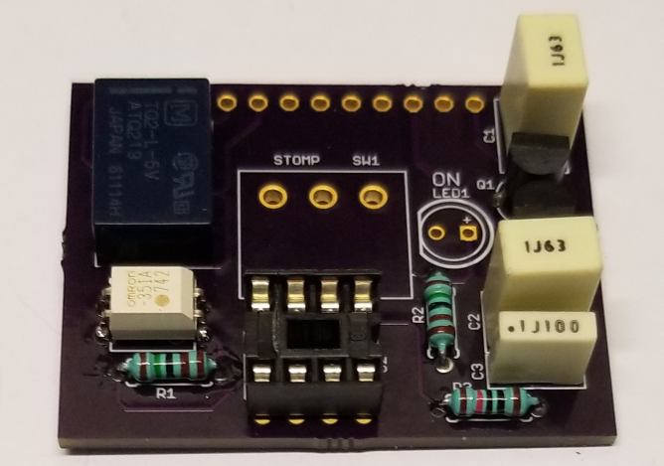

- Next, solder up the stomp switch to SW1
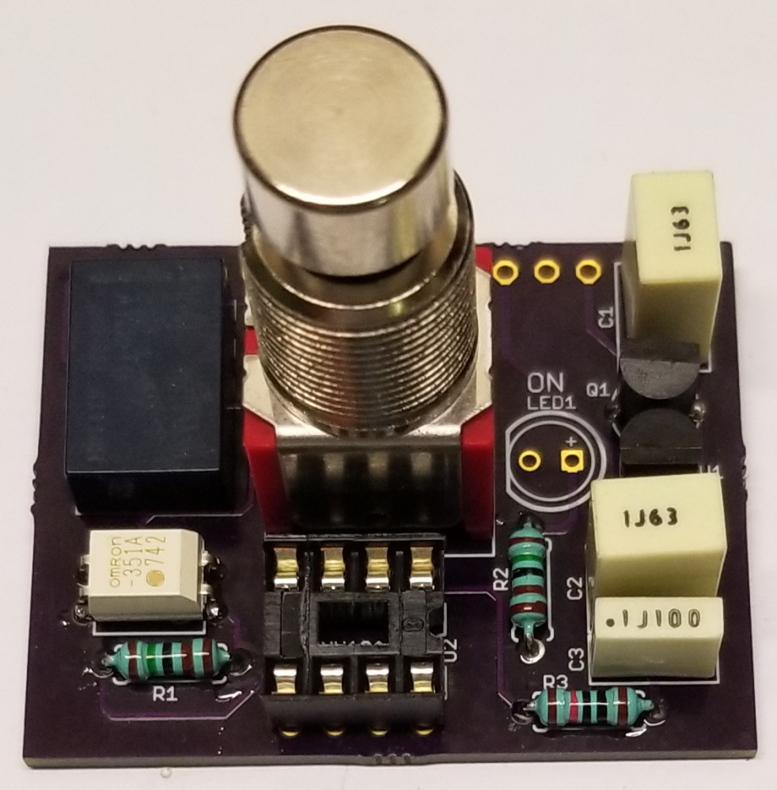

- Next, solder the LED to LED1. It should stand off a little bit as to get it closer to where the stomp switch will be flush-mounted to the box of the pedal.
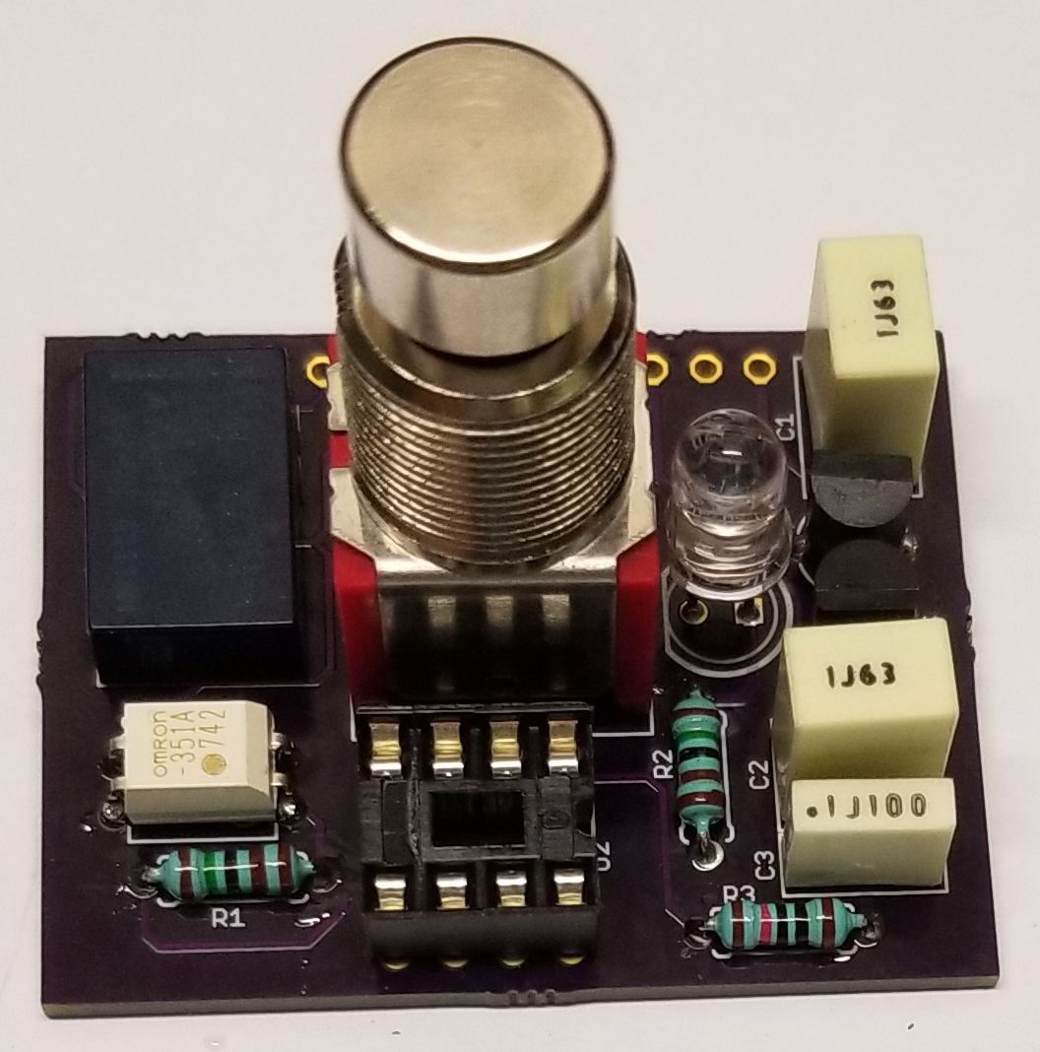

- Next, insert the programmed microcontroller. Make sure the markings are correct.
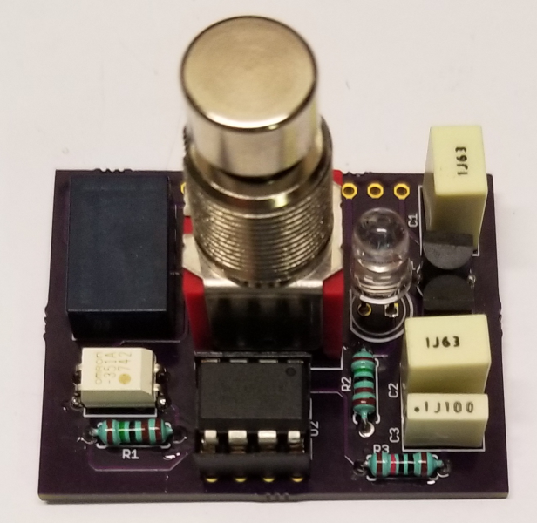

- Flip over to the bottom and note J1 and it’s labels.
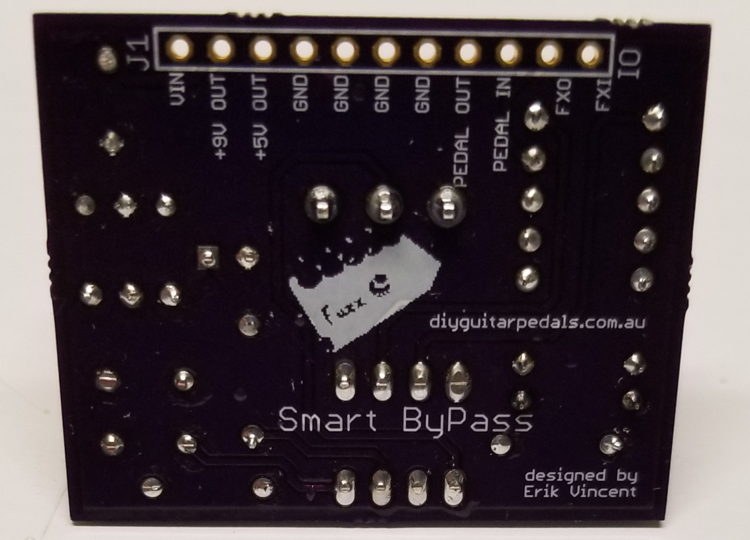

J1 – Header connections
VIN – 9V coming in from battery or wall power
+9V OUT – protected 9V power. This connects to your effect board to provide it 9V power
+5V OUT – protected 5V power up to 100mA. This goes to your effect board if it needs 5V power
GND – this is for common ground components such as power ground, input/output jack ground, and effect board ground. Note, not all grounds may be utilized.
PEDAL OUT – this connects to the output jack’s output signal wire
PEDAL IN – this connects to the input jack’s input signal wire
FXO – this connects to the effect board’s output
FXI – this connects to the effect board’s input

