

Sound2Light

Bill of materials
Resistors | Capacitors
R1 100ohm | C1 10uf
R2 100ohm
 | IC
 | U1 LM386

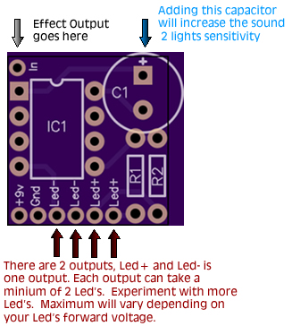

Notes
Please see this thread for more information about the sound 2 light:
http://www.diystompboxes.com/smfforum/index.php?topic=82843.0

Page 1 of 1
www.diyguitarpedals.com.au

