

Tonemaster – Germanium Booster
Based on the Dallas Rangemaster™
Unlike other Rangemaster™ based effects the Tonemaster includes a tone control so it will act as more than just a treble boost and can give you a full range boost! The input tone control is versatile though and can be set up as a classic Rangemaster™, a full range tone control, or both! (See mod notes below). Onboard charge pump is included to save you the hassle of a separate power inverter board or power supply.

Bill of materials
Resistors | Diode
R1 68k | D1 1n4001
R2 3k9
R3 470k | Transistor
R4 1meg | U1 Germanium PNP
Capacitors | IC
C1 100nf (104) | U2 Charge Pump (tc1044scpa)
C2 5nf (502)
C3 100nf (104) | Potentiometer
C4 10uf | Volume 10ka (9mm Log Pot)
C5 100uf | Tone 100kb (9mm Linear Pot)
C6 10uf
C7 47uf

1590a
The Tonemaster PCB is spaced to fit a 1590a enclosure. Compact DC jack is recommended for a 1590a build. 9mm pots can be mounted directly to the board.
Tone mod
The Tone control can be used in a few different ways (See wiring diagram below for a visual guide “Classic Rangmaster Mod”):
- As per BOM, 5nf and 100nf for the input caps will give you a good range to sweep through making this more of a general booster then a treble boost.
- For a traditional treble boost without the tone control, leave off c1 and the tone potentiometer.
- Wire in the tone pot (instead of board mount) and add a spdt to pin 3 of the potentiometer to join / break this connection. This will give you both of the above options.

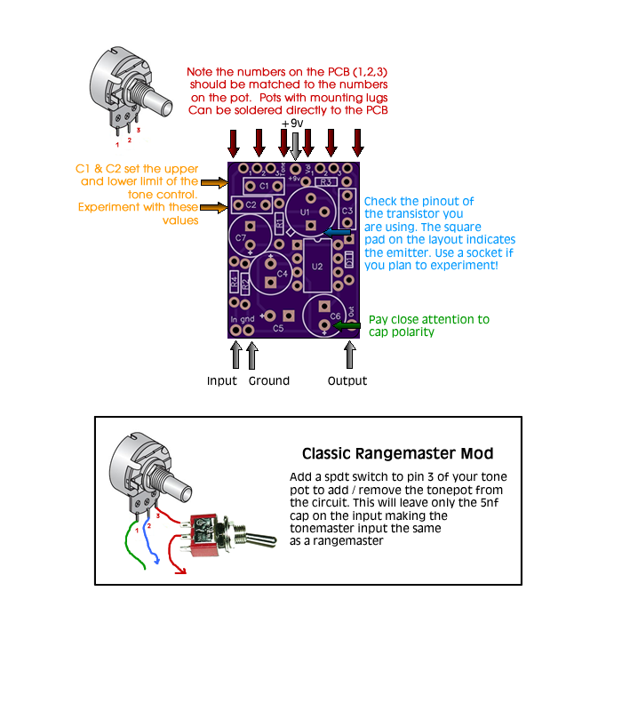

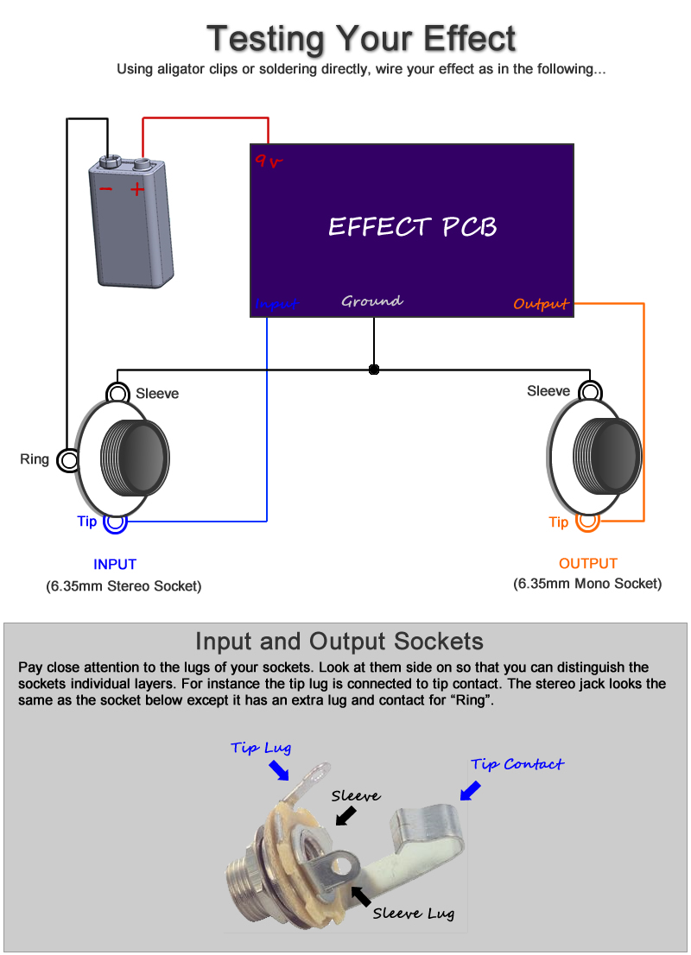

Boxing up your effect

Watch my offboard wiring tutorial for information on wiring this effect up inside an enclosure (with LED, stompswitch, etc)

http://www.youtube.com/watch?v=z6fpwU8RY_0

