

Whipper Clipper
The Whipper Clipper is a faithful reproduction of the Dan Armstrong Blue Clipper. Leave your expectations at the door and take a listen to the sound demo of this surprising ballsy and highly modifiable distortion pedal. Useful as a simple distortion circuit or a booster for a 2 in 1 pedal.

Bill of materials
Resistors | Capacitors
R1 200k | C1 47nf
R2 240k | C2 4.7uf
R3 2.4k | C3 4.7uf
R4 150k | C4 (33nf) See mods!!
R5 8k2 | C5 100uf
R6 10k
R7 2M2 | IC
 | U1 TL071
Diodes
D1 1n4148 | Potentiometer
D2 1n4148 | Volume 100ka

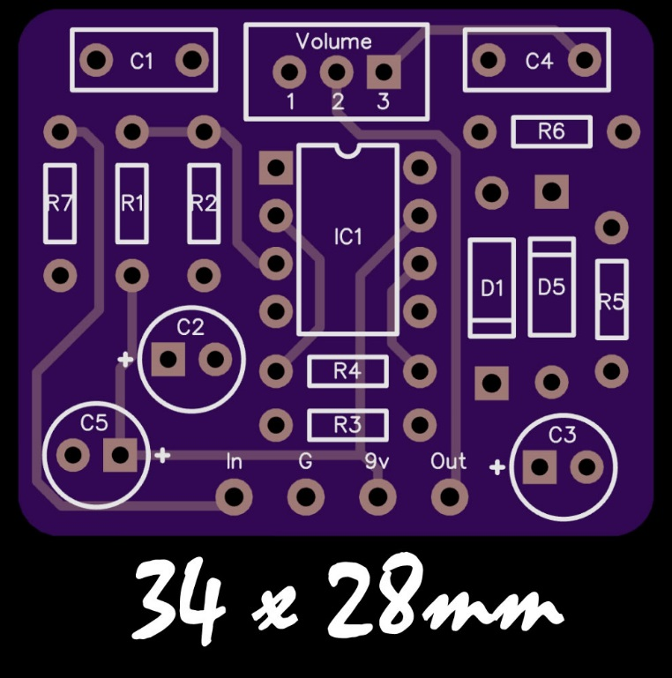

Modifications
The Blue Clipper is a classic non-inverting opamp amplifier with hard clipping on the output (diodes to ground). Here are a couple of simple but worthwhile modifications to the original circuit.

More Treble
A stock Blue Clipper is a very ‘dark’ (lacking treble) distortion pedal. In order to correct this we can decrease C4 to allow more treble at the output. I would recommend this as a MUST modification and would not recommend 33nf as a standard value. 3.3nf is a replacement value that has been suggested, but I found this to be too harsh. You really want to socket this capacitor. Experiment in between these values till you find what suits your preference or use a toggle switch to incorporate a ‘treble boost’ switch!

Gain Control
R4 (in conjunction with R3) sets the gain of the opamp. This resistor could be replaced with a potentiometer for a gain control. Note that you can use your guitars volume control as a pretty effective gain control when the pedal is at the beginning of your pedal chain.
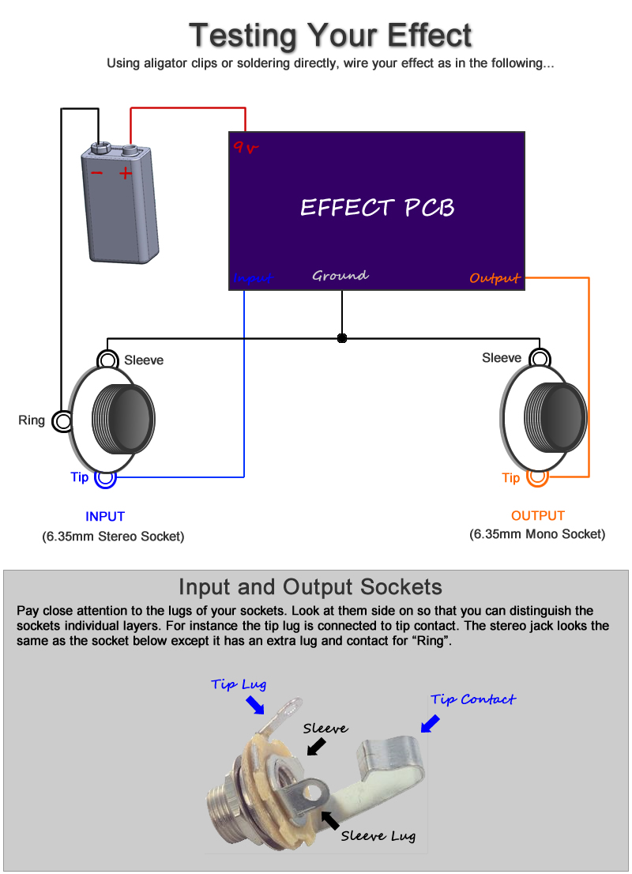

Boxing up your effect

Watch my offboard wiring tutorial for information on wiring this effect inside an enclosure (with LED, stompswitch, etc)

http://www.youtube.com/watch?v=z6fpwU8RY_0

