Whipper Clipper  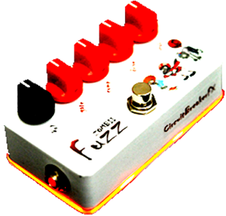  diyguitarpedals.com.au | (Please visit our website for  bill of materials and build instructions)  http://www.diyguitarpedals.com.au/shop/kits
Whipper Clipper  diyguitarpedals.com.au | (Please visit our website for  bill of materials and build instructions)  http://www.diyguitarpedals.com.au/shop/kits

